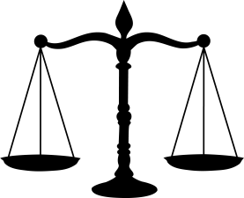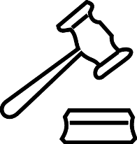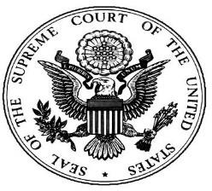Name: Date: Period:
The Judicial Branch

Matching – match the description that identifies the key term:

1. Appeal | a. The main job of the judicial branch
2. Civil Trial | b. The decision reached by a jury
3. Criminal Trial | c. The power to declare laws unconstitutional
4. Dual-Court System | d. To ask a higher court to overturn a trial court decision
5. Interpret the Law | e. A court case where a law has been broken
6. Judicial Branch | f. The power to hear a court case
7. Judicial Review | g. The only court listed in the US Constitution
8. Jurisdiction | h. Our system of national and state courts
9. Supreme Court | i. A court case between individuals over damages
10. Verdict | j. Our nations court system

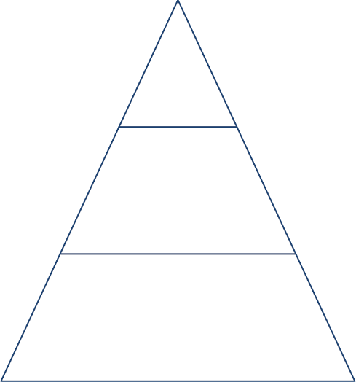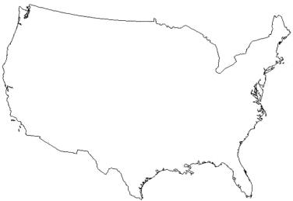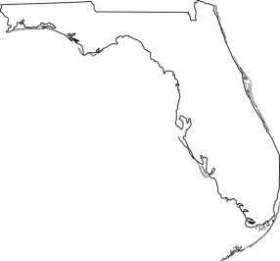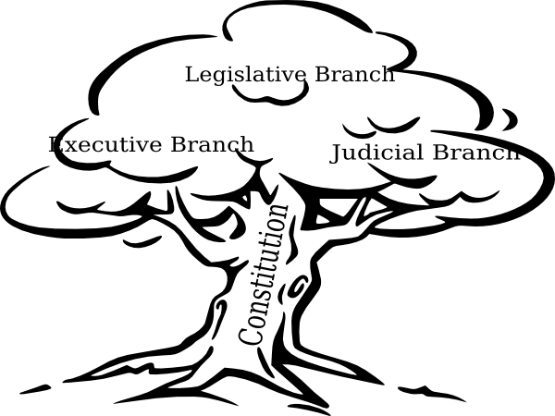Fill out information for the three levels of federal courts:

Name # of judges: Jurisdiction
Name # of judges: Jurisdiction:
Name # of judges: Jurisdiction:

Label the chart below:

Federal Courts State Courts

What “check” does the Judicial Branch have on the other two branches? What court case established this “check”?

