1. Which type of map is this?

a. A physical map

b. A political map

c. A road map

d. A topographical map



2. Which of type of map is this?

a. A physical map

b. A political map

c. A road map

d. A topographical map



3. Which type map is this?

a. A physical map

b. A political map

c. A road map

d. A resource map

4. What can you conclude from the fact that political maps often change, but physical maps rarely do?

a. Political borders change more often than natural landmarks

b. Physical maps are updated far more frequently than political maps

c. Political mapmakers are constantly seeking out new information about geography

d. Every time there is an election, a political map must be updated

5. If you're having trouble figuring out what the symbols on a map represent, where would you look?

a. The back of the map

b. The title of the map

c. The map legend

d. The compass rose

6. What's an example of a label you might find on a political map?

a. The name of a country

b. A symbol that shows you which way north is

c. A little picture that represents a capital city

d. A line of latitude

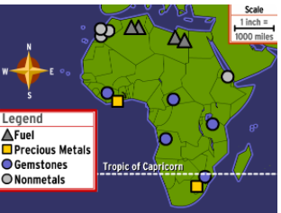7. On the following map, what do the grey triangles represent?

a. Sources of fuel

b. Gold mines

c. Areas where precious gems can be found

d. Areas where nonmetals can be found

8. On this map, the circles, triangles, and squares are all examples of:

a. Legends

b. Keys

c. Roses

d. Symbols

9. A map's scale shows that 1 cm equals 10 km. Two cities are 2 cm apart on the map. How far apart are they in real life?

a. 10 km

b. 20 km

c. 200 km

d. 2000 km