Name:
Date:

- Four students are painting a wall mural for their school. Each student paints square yard of wall space. What is the total area of the wall mural that is being painted?

A. square yard
B. square yards
C. square yards
D. square yards

- A rectangle has a width of 21
4
inches and a height of 5 inch. Which of
8

the following equations describes the area of the rectangle.

A. square inch
B. square inches
C. square inches
- square inch

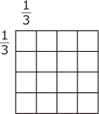
- Juanita is making a quilt to use as a picnic blanket. Each quilt square is yard by yard.

What is the area, in square yards, of Juanita's quilt?

  - square yards

B. square yards
C. square yards
D. square yards

- Stephanie draws a rectangle with a width of and a length of What is the area of the rectangle?

A. square inches
B. square inch
C. square inch
D. square inch

- Mr. Bryce is starting to plant a garden in his backyard. The length and width of the garden that he has planted so far is shown.
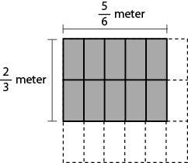

What is the area, in square meters, of Mr. Bryce's garden?

- $\frac{5}{9}$ B. $\frac{7}{9}$ C. $1\frac{1}{2}$ D. $1\frac{2}{3}$

9
- Mr. Mccgraw bought gallon of milk. His family members
drank of the milk for breakfast. How many gallons of milk did they drink?

A. gallon
B. gallon
C. gallon
D. gallon

