The ABC’s of Water Safety

**PART 1: Introduction - AM**

|  |  |
| --- | --- |
| What are the ABC’s of water safety?  The most important things you do to stop a drowning is to think safe around water and practice the ABC’s of Water Safety. Think about all the times you are around water. When were you around water today? When you took a bath? When you played near the water fountain at the mall? When you went swimming at your pool? Those are all times you and the adults around you need to be aware of the danger of drowning. |  |

What does it mean to be aware? Being aware means knowing what’s happening around you and taking action to be safe. Like when you are on a busy street corner, you know that there are cars all around you and you look both ways before you cross the street. Being aware of water means doing the same thing. You know that water can be dangerous and you take action to be safe. How can you take action to be safe around water? Do the ABC’s of Water Safety. It’s really pretty simple. Just follow these rules:

**A is for ADULT!** An adult must always be with you around water. The adult must watch you with their eyes and not be doing anything else! They shouldn’t be reading, talking on the phone, or doing chores like yard work or washing the car.

**B is for BARRIER!** A barrier is something that keeps you away from danger. A few examples of barriers around water are a locked fence around a pool or a closed lid on a toilet or a door leading to the bathroom. A pool fence with a broken gate is not a barrier because you can get into danger. An open bathroom door is not a barrier because a small child could get into the full bathtub.

**C is for CLASSES!** You need to take swimming lessons so you can learn how to swim! Older kids and adults should take CPR classes so they know what to do incase of an emergency.

It is important to be a good example for water safety. If you learn to be aware around water and practice the ABC’s of Water Safety, so will the rest of your family. You can help prevent a drowning by thinking safe around water - have an **ADULT** watch you, have a **BARRIER** around water, and take **CLASSES**.

**PART 2: Together**

*Take notes while you watch the videos below.*

A = <https://www.youtube.com/watch?v=hVoIxa5JqPg>

B = <https://www.youtube.com/watch?v=KZ5KbrULGcI>

C = <https://www.youtube.com/watch?v=elibyFtAmaI>

*Discussion questions:*

Why do most drowning’s happen?

When do most drowning’s happen?

**PART 3: Your Turn**

*Complete the puzzle below:*

|  |  |
| --- | --- |
| **The ABC’s of Water Safety**  *Cross-Word-Puzzle* | |
|  | |
| **ACROSS:**  3. Must always be with you around water.  6. Should watch you at all times.  7. You can help prevent drowning by ____ ____.  9. When you see this, call 911.  10. Something that keeps you away from danger. | **DOWN:**  1. You take _____to be safe.  2. You must follow these when you're around water.  4. You need to take these to learn how to swim.  5. The most important thing to stop is.  8. Knowing what's happening around you. |

*To be continued…*

Personal Flotation Devices

**PART 1: Introduction - PM**

|  |  |
| --- | --- |
| What are personal floatation devices?  Life jackets, also known as personal flotation devices (PFDs), are not just for boats. Unless under direct supervision in a designated swimming area, young children and weak swimmers should wear life jackets whenever they are in, on or around the water.  People who cannot swim well should wear a life jacket whenever they are near the water as well. Even in public pools or waterparks, people with little or no swimming ability should wear one. All life jackets should be U.S. Coast Guard approved and in good condition. If the life jacket is U.S. Coast Guard approved, it will be marked on the device. |  |

Because most boating emergencies happen suddenly, everyone on a boat should ALWAYS wear a life jacket. Local laws may even require wearing one. Put your life jacket on at the dock and do not take it off until you return, because it is difficult to put a life jacket on while in the water! It is also a good idea to practice putting one on to be sure that the life jacket fits correctly and is worn properly. Practice swimming with it in shallow water. Even good swimmers should wear a life jacket in any situation where there is a chance of falling or being thrown into the water, especially if the water is cold. Most states require that life jackets be worn for anyone being towed on water skis, tubes or similar devices, and while operating or riding on a personal watercraft (PWC).

**PART 2: Together**

*Take notes while you watch the video below.*

<https://www.youtube.com/watch?v=YNj_qKK0wxc>

*Discussion questions:*

Who should wear life jackets?

When should life jackets be worn?

**PART 3: Your Turn**

*Analyze the table below. Choose two types of flotation devices to compare and contrast. Complete the Graphic Organizer.*

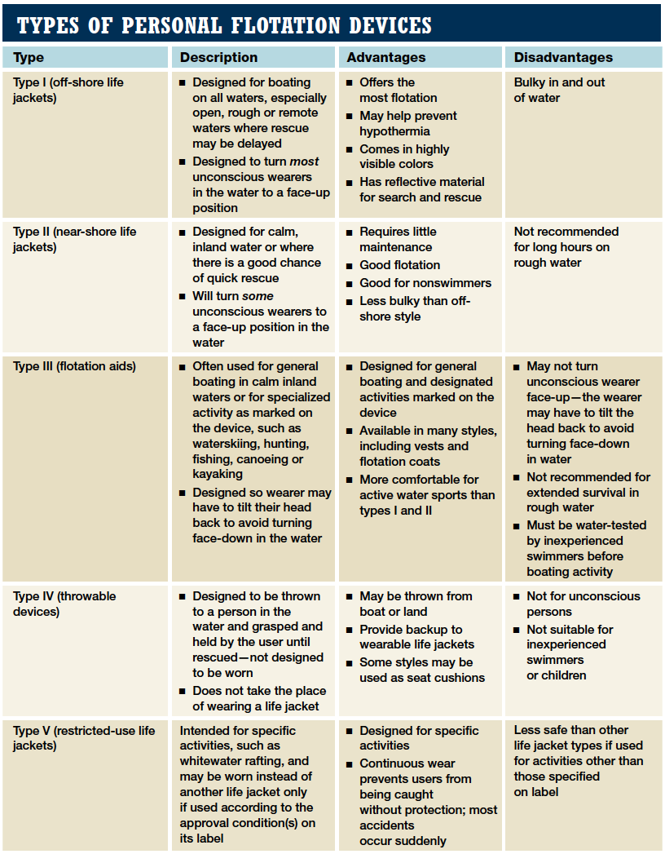

|  |  |  |
| --- | --- | --- |
| Flotation Device #1 | Both | Flotation Device #2 |
|  |  |
|  |  |  |

Upload the completed assignment to the BridgePrep website as a PDF document.

If you have any questions, contact me through ClassDojo or the BridgePrep website.

Thank you and be safe!

**Mrs. Estevez and Mr. Nuñez**