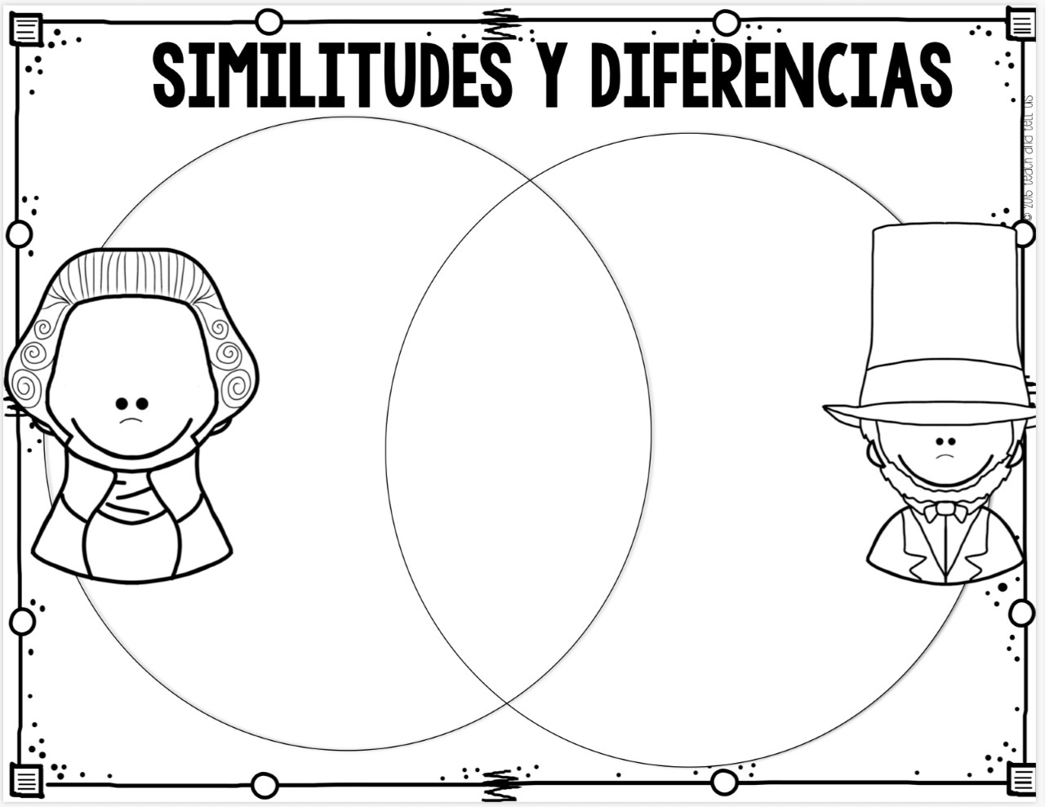
Presidentes: George Washington y Abraham Lincoln
Presidents: George Washington and Abraham Lincoln
- Comparar y contrastar. Completa el diagrama de Venn. (Compare and contrast. Complete the Venn Diagram).

Diferencias de George Washington
(Differences) Diferencias de Abraham Lincoln
Igual (Differences)
(Same)
- _________________ 1. ____________ 1. _______________________
___________________ ____________________ _________________________

- ____________ 2. _________________________ 2. __________________
___________________ ___________________________ _______________________

- _____________ 3. ____________________ 3. ______________________

___________________________ ________________ ____________________________________

George Washington
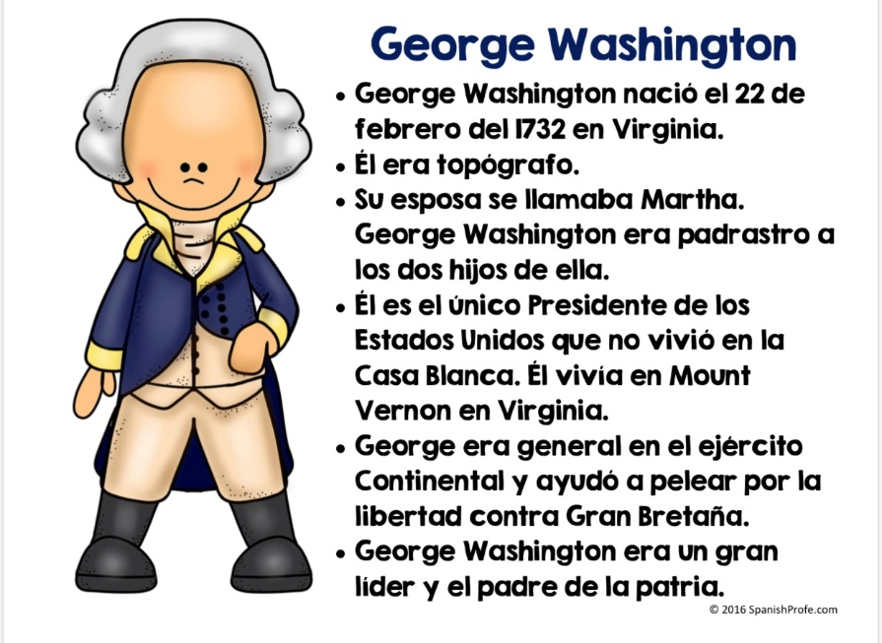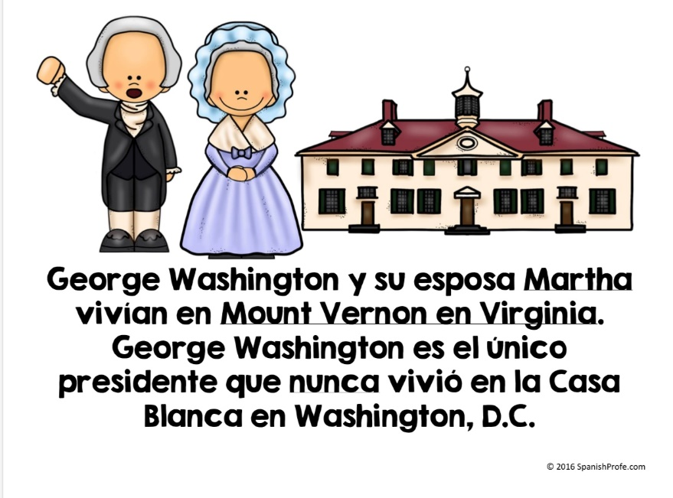
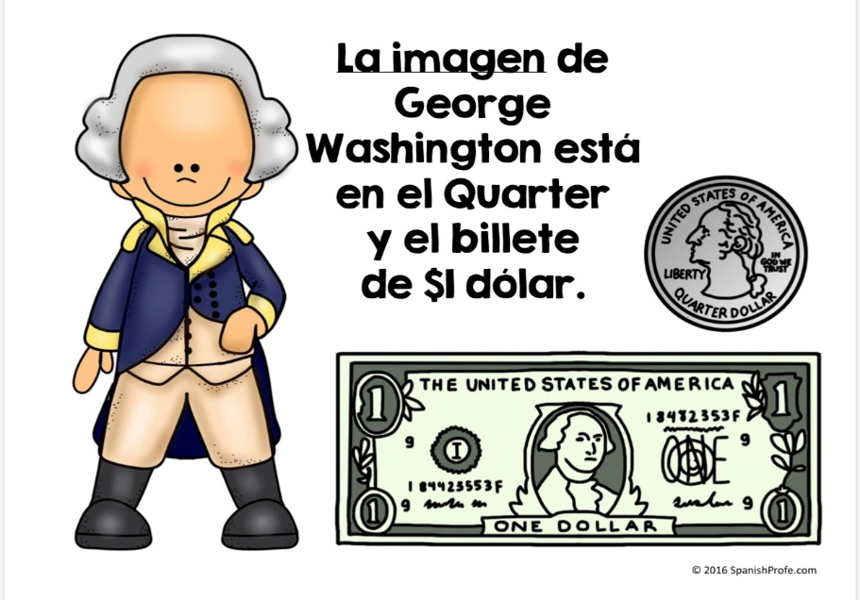
Abraham Lincoln
