Name:
Date:

- During the annual Bluebell 5k, Cindy noticed that
5
of the 4

runners fell under the age group of 30 years old or younger. Out of
3

that age group,
4

were women.

Which diagram represents the fraction of women runners who are 30 years old or younger at the Bluebell 5k? Select two that apply.

A.

B.

C.


D.


E.

2

2.Which fraction model best represents 3 × ?
6


A.


B.


C.


D.

3. Shelley pours $\frac{4}{5}$ gallon of water into a bird bath. The next morning,
she finds that of the water is gone. What is the amount of water, in gallons, that is gone?

A.
B.
C.

D.

4. Robby had bags of pet food. All of the bags held the same amount of food when they were full. Of Robby's bags
of pet food, were dog food. How many bags of dog food did Robby have?

A.

B.

C.

D.

5. On a rainy day, Parker and his mom watched movies for hours.
They played games for times as long as they watched movies. How many hours did Parker and his mom play games?

A. 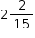hours
B. hours
C. hours
D. hours

21. A carpenter needs 4 1 strips of lumber for a project. Each strip is to
2
measure 1 𝑚𝑒𝑡𝑒𝑟. How many meters of lumber does the carpenter need
in all?
3

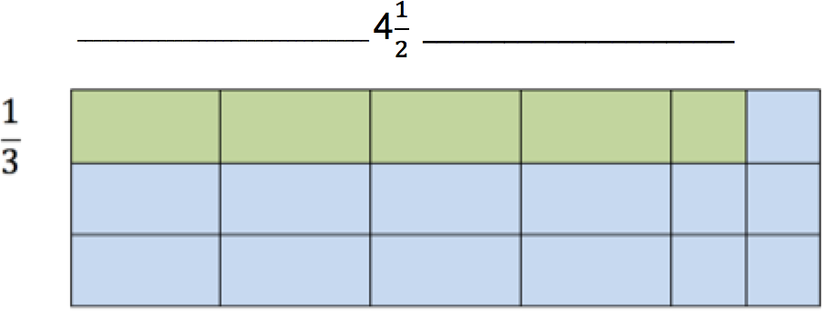

- 4 5
6

- 1 1
2

- 1 1
3

- 5
6


You have reached the end of this section.

