**Carnegie Mathia**

Website <https://www.carnegielearning.com/login/#/>

1. Click set your password:

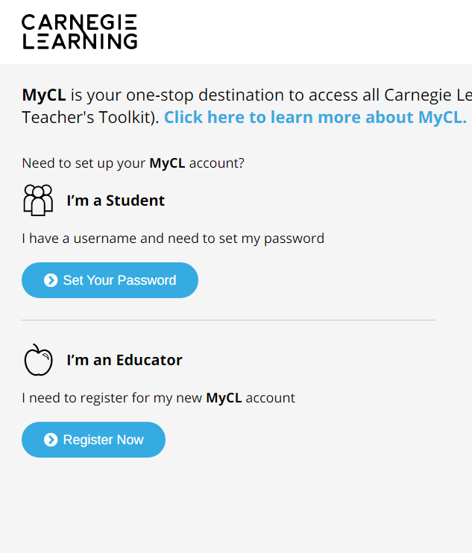

1. Add username (sended by teacher) and School name (BridgePrep Academy of Osceola)

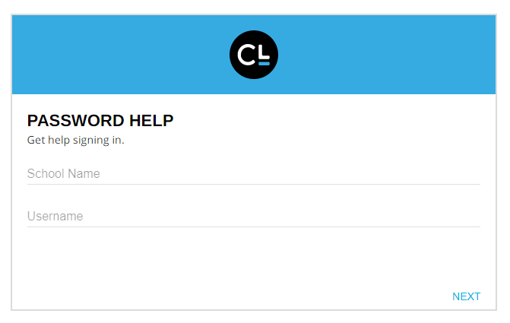

1. Create your own password

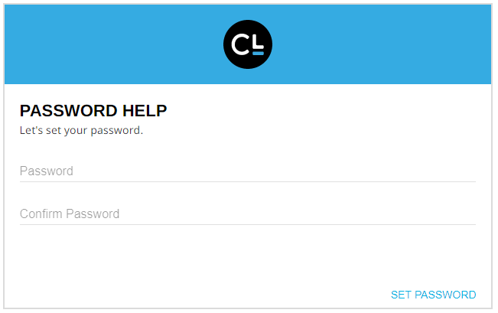

1. Start working!! 😊