**Carnegie Edulastic**

1. Website: <https://app.edulastic.com/login#login>
2. Username (same as Mathia)

Password: math6grade

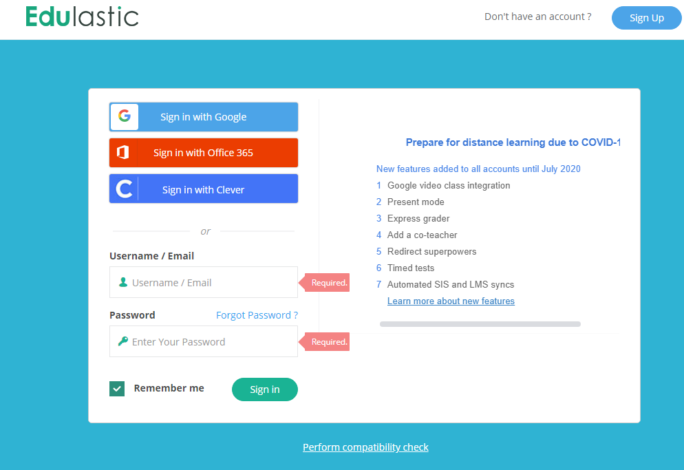

1. Add class code: **FULUF**; if requested

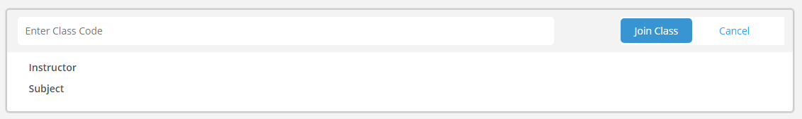

1. Let’s start working! 😊