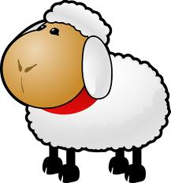
Sheep in A Jeep
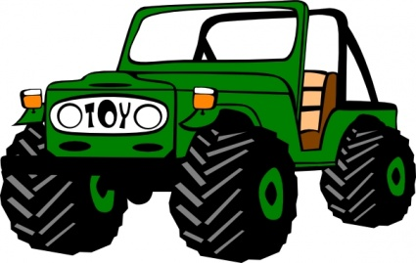
Sheep in a jeep on a hill that’s steep. Uh-Oh, the jeep won’t go. The Sheep leap to push the jeep. The Sheep shove, the Sheep grunt. The Sheep don’t think to look up front. The jeep goes crash! The jeep goes thud! The jeep goes deep in gooey mud. The Sheep tug. The Sheep shrug. The Sheep yelp. The Sheep get help and the jeep comes out. The Sheep shout. The Sheep yell, Oh Dear! The driver Sheep forgets to steer. The jeep’s in a heap. The Sheep weep. The Sheep sweep the heap. Jeep for sale-Cheap!

