Name ________________________ Date __________________
My Poetry Menu
Step 1: Reread the poem out loud to a parent, sibling, or stuffed animal.
Step 2: Pick 4-5 activities from the menu to complete.
Step 3: Have your parent initial the menu items you did.

Write a story about the poem using the same characters.    Parent X________________ | Circle all the rhyming words in the poem. Use different colors to show which words rhyme. Example: circle “cat” and “mat” in red and “sit” and “mit” in blue.  Parent X________________ | Underline 2-3 words you don’t know and have a parent help you look up what the words mean.  Parent X________________
Read your poem in a silly voice:  -Whisper  -Baby talk  -Animal  -Singing  Parent X________________ | Write the poem in your own handwriting and draw a picture to go with it.    Parent X________________ | Give the poem a new title. Then add another sentence or line to the end of the poem.  Parent X________________
Read the poem and act it out as you go. Act out what is happening in the poem and pretend to be the characters.  Parent X________________ | Put a box around words with the same spelling pattern. Look for double letter patterns like “ee” “ow” “ly” and “ch.” Any pattern will do!  Parent X________________ | First read the poem in slow motion. Then read it as fast as you can!  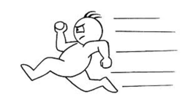  Parent X________________

