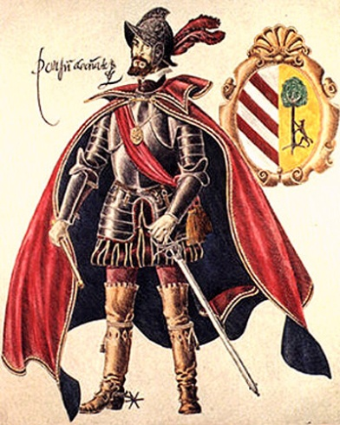

Explorers Wanted Poster

Explorers as we have been discussing during this chapter are people who set out to discover new lands, places and people. They were not sure what the world had in store for them. Many explorers came from Europe and they tended to be men because of the societal constraints of the time.

You will get to choose an explorer. You will use the internet to learn more about your explorer.

Using the information you discover you will create an Old West Wanted Poster to share with your classmates. I will choose the best ones to put up on display in our classroom.

**Poster cant exceed the size of a sheet of paper.**

Information to include:

Name of explorer

Birth & death date

Country of origin

Facts about their lives: education, early life, how they became an explorer

What country did they explore for

Did they have any partners?

Is there anything named after them?

Picture of explorer

Greatest accomplishment

Interesting facts about them

You will come up with a REWARD for their capture, this could be something like the West Indies, gold, anything related to your explorer.