Name:

Select the main idea of each passage.

Elephants
1

By Elsa Posell

Elephants are the largest of all land animals. An elephant may weigh as much as sixty men. Elephants have dark gray skin about an inch thick. There is little hair on an elephant’s hide, but its long tail ends in a tuft of wiry hair. Because it is so big, an elephant has legs that are like thick, strong posts. Elephants have small eyes and do not see well. They spread their large ears to catch sounds. They lift their long trunks to catch the smells that tell them of danger, or where to find food or other members of the herd. An elephant’s trunk is part of its nose and top lip. It has nostrils at the end of it. It is almost six feet long. The trunk is a tube with a tab like finger at the end of it. An African elephant has two tabs at the end of its trunk. An elephant uses these tabs as we use our fingers. It touches and feels things with them. A thirsty elephant draws water into its trunk. Then it blows the water into its mouth. When flies are biting an elephant may give itself a shower. It fills its trunk with sand or mud blows it all over its huge body. Elephants take care of their trunks. Sometimes they curl them up to protect them from danger. An elephant’s tusks are two overgrown front teeth. Tusks of an African elephant may be over six feet long and weigh a hundred pounds each.

- How many kinds of elephants there are
- What elephants look like
- Where elephants come from
- What elephants eat

Polar Bears
2

By Emilie U. Lepthien

Polar bears live in the Arctic. They like areas near the shore, where pack ice forms. They use the pack ice as seal-hunting platforms. Between 3,000 and 4,000 polar bears live along the northern coast of Alaska. Canada has about 15,000. Polar bears are also found along the coasts of Norway and its Svalbard Islands, in Greenland, and in Siberia in the Soviet Union. Polar Bears have special features that help them to survive in the frozen north. Their creamy white fur provides good camouflage. The bears cannot easily be seen. Their thick fur protects them from the cold. The outer layer of fur has special guard hairs that shed water easily. Their dense underfur protects them from the cold. The thick layer of blubber, or fat, under their skin also keeps them warm and allows them to go for weeks without eating if necessary. Polar bears shed their winter fur and grow a thinner summer coat that is yellow or golden in color. By winter they have heavy, new white coats again.

- What polar bears look like
- Where polar bears live
- How polar bears survive in the cold
- The future of the polar bear

Reptiles
3

By Lois Ballard

Turtles are reptiles. Turtle shells are made of scales. There are many kinds of turtles. Some kind live on land and some live in water. Mud turtles live in mud. They are not easy to see. They are the same color as mud. Snapping turtles live in water. They eat fish and plants. Box turtles live on land. Their bottom shells can move. They are able to close themselves like boxes. This helps protect them. Box turtles eat insects, worms, and berries. Soft-shelled turtles have soft shells. They are flat like pancakes. Some people think that they are good to eat. Sea turtles live in the ocean. They grow to be very big. A sea turtle may weigh as much as a horse. Desert tortoises live in dry places.

- How reptiles are alike
- How reptiles are different
- Reptiles with shells on their backs
- Reptiles with four legs that live on land

Australia
4

By D. V. Georges

Australia is the only continent that is just one country. Unlike other continents, it has only one main language – English. In the 1600s, Dutch explorers touched the north, west, and south coasts of Australia. They found dry, flat land. The Dutch called the land “New Holland,” but they did not claim the land for Holland. The Dutch explorers did not know that the east coast of Australia was different. It had mountains and a rainy climate. In 1770, Captain James Cook sailed his ship Endeavour along the east coast of Australia. He claimed this land for Great Britain and called it New South Wales. By 1827, Great Britain had claimed all of the continent. It was named Australia, from the Latin word australis, which means “southern.” Australia’s north shores are one thousand miles south of the equator. Thus, the whole continent is in the Southern Hemisphere. Eventually, thousands of people from Great Britain moved to Australia. But at first, only prisoners were sent there. Most of the prisoners were sent to southeast and west Australia. They helped build roads and buildings for the newly discovered continent.

- How Australia was found
- A new continent and country
- All about the outback
- All about Australian animals
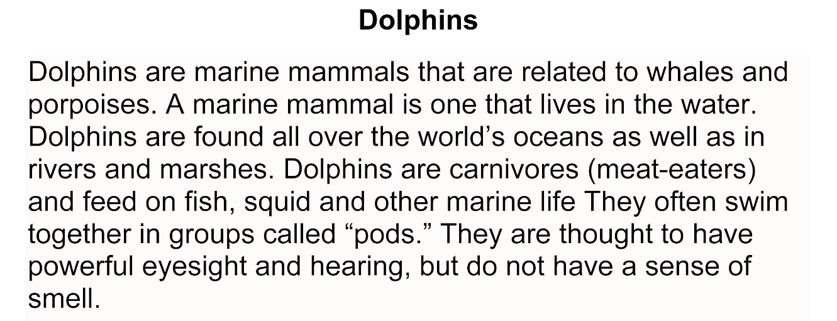
5.

- A marine mammal is one that lives in the water.
- Dolphins are marine mammals that are related to whales and porpoises.
- Dolphins do not have a sense of smell.
- Dolphins are found all over the world.

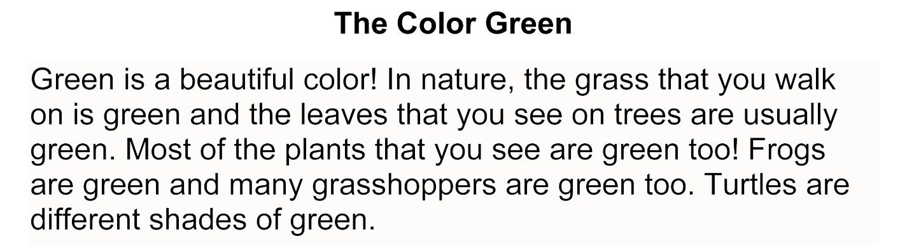
6.

- Green is a beautiful color!
- Most plants, grass, and leaves are green.
- Frogs are green and many grasshoppers are green too.
- Turtles are different shades of green.

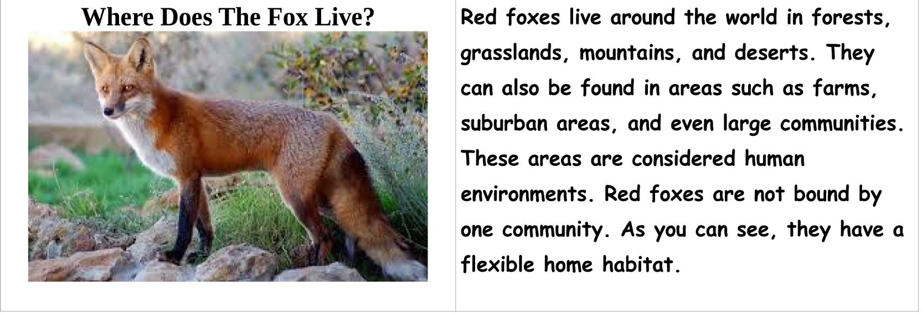
7.

- These areas are considered human environments.
- Red foxes are not bound by one community
- Red foxes live around the world in forests, grasslands, mountains, and deserts.
- They can also be found in areas such as farms.

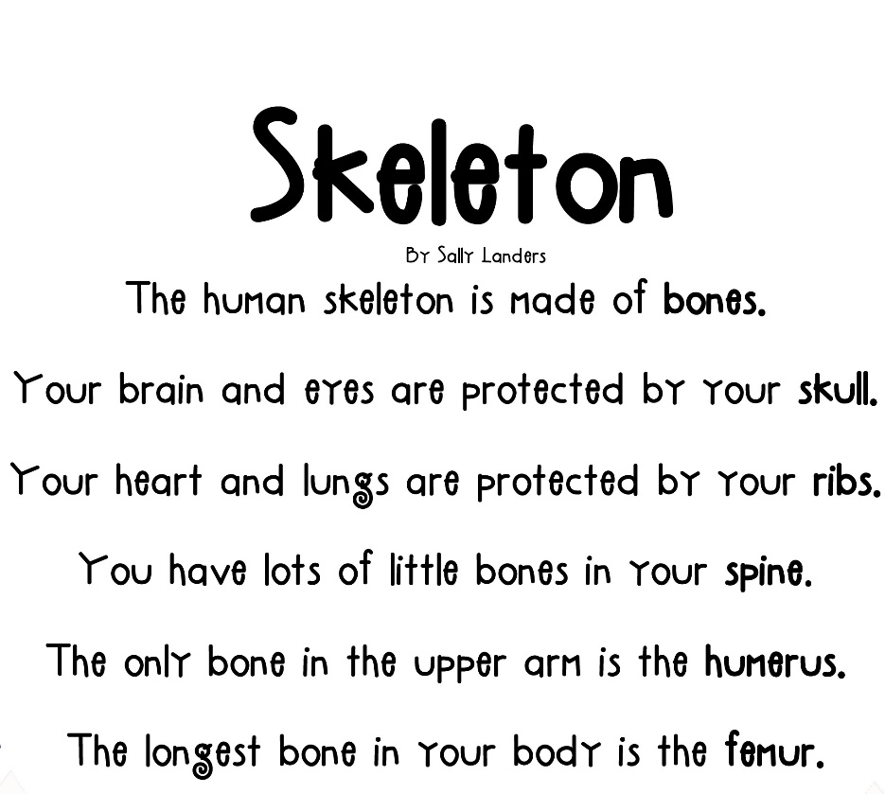
8.

- Your heart and lungs are protected by your ribs.
- The human skeleton is made of bones.
- The longest bone in your body is the femur
- You have lots of little bones in your spine.

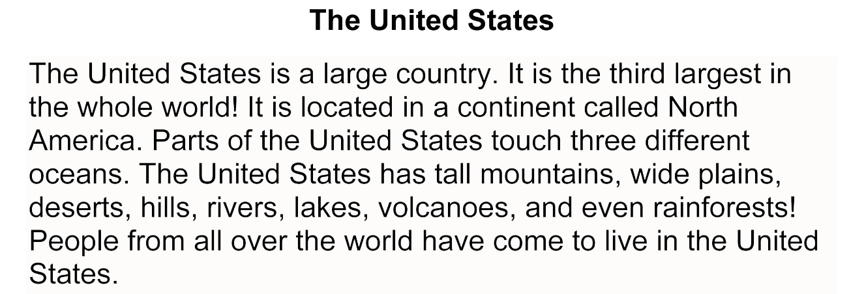
9.

- The United States is a large country.
- Parts of the United States touch 3 different oceans.
- It is the third largest country in the whole world!
- People from all over the world have come to live in the United States.

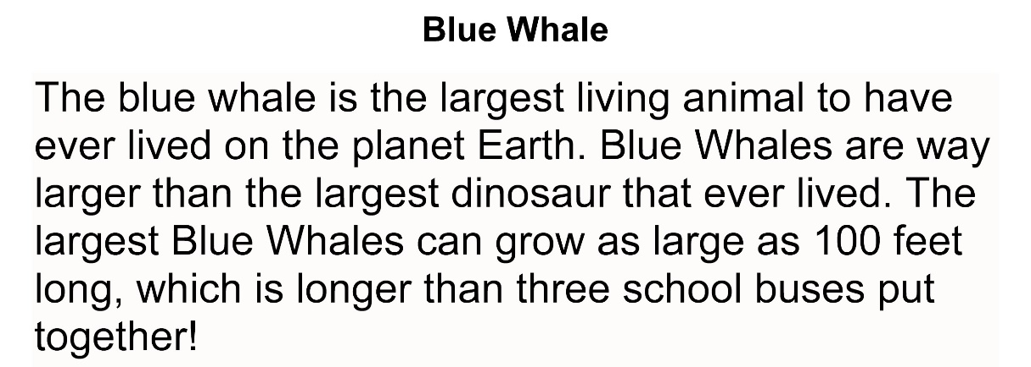
10.

- Blue whales are way larger than the largest dinosaur that ever lived.
- The blue whale is the largest living animal to have ever lived on the planet Earth.
- The largest blue whales can grow as large as 100 feet long.
- They are longer than 3 school buses put together.

Owls
Owls are nocturnal birds. They hunt at night and sleep during the day. Owls can see very well in the dark. They can also hear very well. Owls are smart hunters! They hunt small prey such as snakes, mice and rats.
11.

- They hunt at night and sleep during the day.
- Owls can see very well in the dark.
- Owls are nocturnal birds.
- Owls are smart hunters!

12.
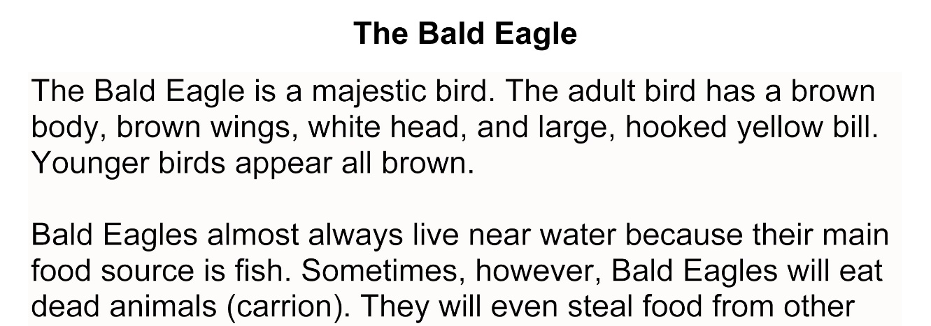

- The Bald Eagle is a majestic bird.
- Bald Eagles almost always live near water because their main source of food is fish.
- Sometimes, however, Bald Eagles will eat dead animals (carrion).
- Younger birds appear all brown.

