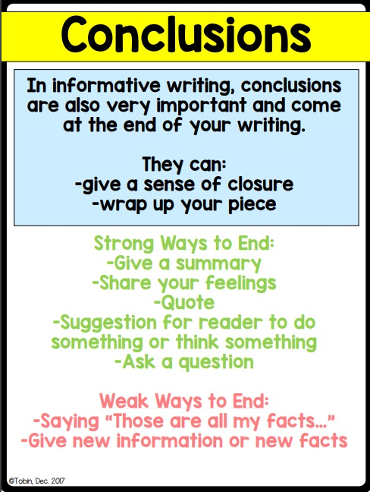

Examples of Conclusions:

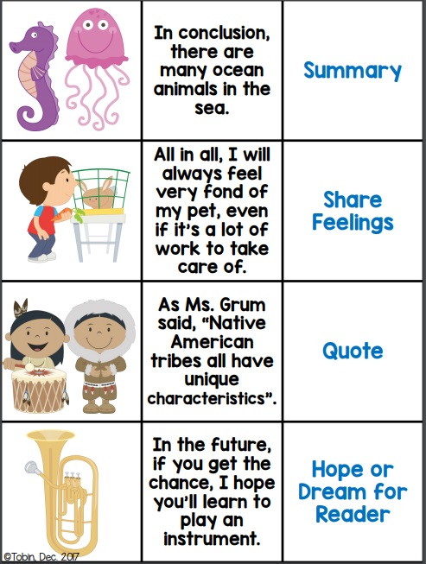

Conclusion 1:

Conclusion 2:

Conclusion 3:

