- Look at the picture below.
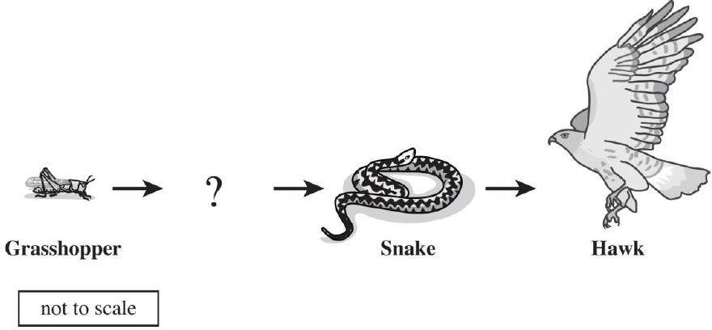

Which organism will best complete this food chain?

A. | 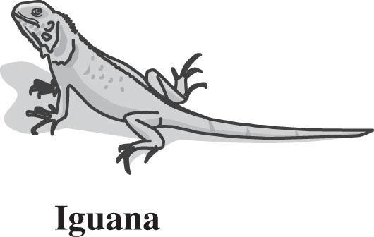 | C. | 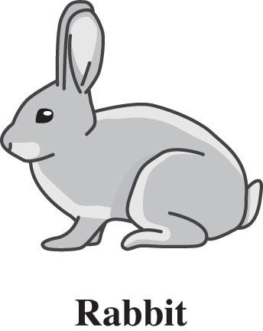
B. | 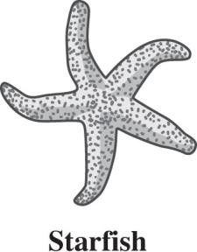 | D. | 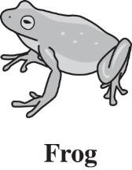

- The stem of a plant is useful for holding up the plant. Animals also have structures that give them support. Which of the following structures has a function most like the stem of a plant?

- The skeleton of a human

- the outer ear of a rabbit

- the fins of a fish

- the tooth of a shark

- A skeleton provides structural support for the human body. An exoskeleton provides support for the body of a crawfish. How are these two structures different?

- A human skeleton is soft, but a crawfish’s exoskeleton is hard.

- A human skeleton is internal (inside), but a crawfish’s exoskeleton is external (outside).

- A human skeleton transports blood in the body, but a crawfish’s exoskeleton does not.

- A human skeleton is involved in digestion of food, but a crawfish’s exoskeleton is not.

- Several parts of a flowering plant are shown below.

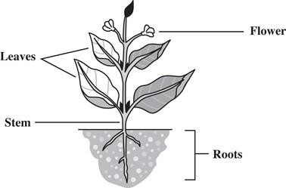

Which part of the plant produces food for the rest of the plant?

- flowers

- leaves

- roots

- All living things use energy. What kind of energy does a plant use to make its food?

- electrical

- light

- magnetic

- mechanical

- Connor has observed the life cycles of two insects: darkling beetles and dragonflies.

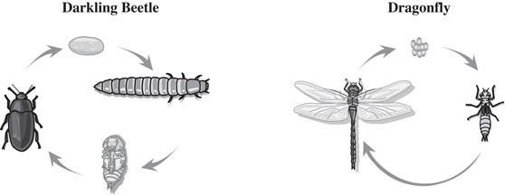

What stage does the darkling beetle go through that the dragonfly does not?

- adult

- egg

- nymph

- pupa

- Most plants have a waxy covering that helps protect the plant from losing too much water. Which of the following human structures is most similar in function to the waxy covering of plants?

- bladder

- bones

- hair

- skin

- Look at the food chain below.

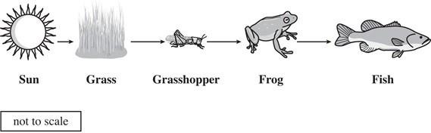

Which of the following identifies the transfer of energy from a producer to a consumer?

- frog to fish

- grass to frog

- grasshopper to fish

- grass to grasshopper

- Most plants have a waxy covering that helps protect the plant from losing too much water. Which of the following human structures is most similar in function to the waxy covering of plants?

- bladder

- bones

- hair

- skin

- The following group of animals ( amphibians, birds and mammals) are vertebrates?

- True
- False

