Name Date

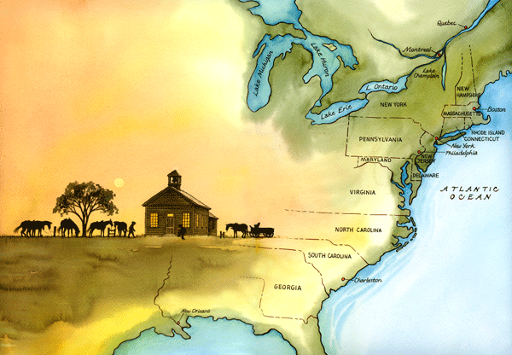13 Colonies Brochure Project

There were many different reasons why people decided to move to the American Colonies. We have learned that the first colonies were begun by businesses hoping to make money and by religious groups looking for freedom. Some of the thirteen colonies were not even started by the English. Because of these differences, each of the thirteen original colonies has a unique history and character of its own. As we learn about the founding of the thirteen colonies it will be your job to investigate one specific colony in detail. Your investigation will be collected in a colonial brochure advertising your colony and showing why it is the best colony to live in. In order to complete this project you will need to follow the guidelines listed below.

**First, Choose a Colony (1 per student)**

New Hampshire New Jersey Maryland

Massachusetts Pennsylvania Virginia

New York Connecticut North Carolina

Rhode Island Delaware South Carolina

Georgia

**Making a Brochure**:

Using information from your textbook, notes and internet research, it is your responsibility to make a brochure about 1 of the 13 Colonies. Your purpose is to inform others as to what life was like in your particular Colony during this early time period of American history and what grievances they had, that made them come to the colonies.

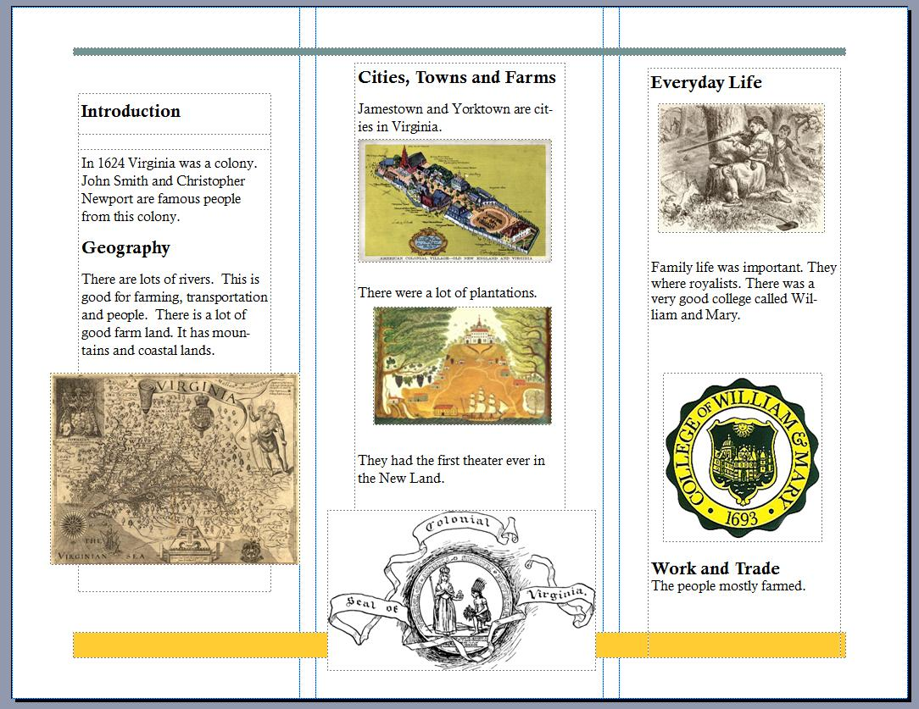

**Front Cover:**

The front of your colony brochure should be designed to grab the attention of the reader. The design of the cover is up to you, but must include the information listed below. All artwork must have something to do with the colony.

1. Colony name

2. State slogan and illustration

3. Your heading (Name, period, date)

**Part I: Government:**

In this section you will report on the type of government your colony chose. Be sure to answer the following questions as part of your report…

1. Who were the important leaders of your colony?

2. Who founded the colony and why?

3. What type of government did your colony have?

4. How did your government grow and change over time?

**Part II: Religion:**

Many settlers came to the colonies for religious reasons. Every colony had certain religious groups that chose to live there. Identify and report on the religious group(s) of your colony. Be sure to answer the following questions as part of your response.

1. What religious groups lived in your colony?

2. Describe what their religion was like.

3. How did the colonists feel about religious freedom? Did they tolerate other religions? Or did they persecute other religions?

**Part III: Economy:**

****Every colony needed to find a way to make money. As a new colonist you would need to know what types of jobs are available in your new home. While reporting on the economic opportunities in your colony, be sure to cover the following questions…

1. What natural resources are available in your colony?

2. What types of businesses would do best in this colony?

3. What goods could someone make and then trade?

**Part IV: Geography**

In this section you should describe the geographic features and climate of your colony. Be sure to include the following…

1. How does the geography and climate contribute to the development of the colony?

2. Be sure to include a map.

3. What economic advantages might the geography give your colony?

**Part V: International Relations**

In this section you will need to include how your colony dealt with both Native Americans and any other European nations that they had interactions with. Be sure to include the following…

1. Important figures
2. Timeline of events
3. How the interactions affected the development of the colony, for example result of conflict, laws enacted, internal strife and their relationship with England.