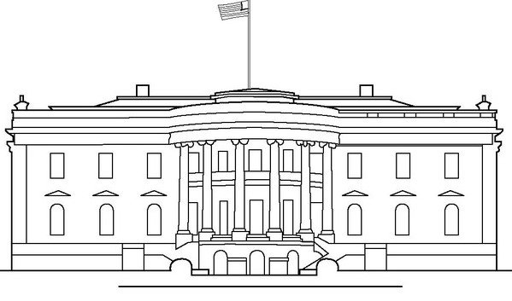
Name: ______________________________________ Date: ___________________ Period: __________

The Executive Branch
Fill in the Blanks

The executive branch is headed up by the ___________________________________.
The main job of the executive branch is to _______________________ the law.
The group of presidential advisors, known as secretaries and heads of the 15 executive departments, is the ____________________________.
Every year the president gives a speech to Congress, as mandated by the US Constitution known as _____________________________________________________.
The president has the power to reject or deny laws known as the _____________.
The president is in charge of making formal agreements with other countries known as _______________________.
The president appoints these people to their jobs: ____________________________.
Presidential appointments and treaties must be confirmed by: ______________________________.
The president can forgive someone who has committed a crime which is known as a ______________________________________.
The president has this power which has the strength of law ___________________ ___________________________________________.
True or false: The president has the power to “declare war”? __________________
The president can be removed by Congress which is known as ____________________________________.
This position which is considered a sort of “back-up” role to the President is actually the head of the Senate? ___________________________________________.
The names of the current President and Vice President are: ___________________ ______________________________________________________________________________
Match the Cabinet Position with a responsibility:
- Attorney General | - Formed after 9/11, responsible for protecting America from terrorists
- Secretary of Agriculture | - Ensures safe working conditions
- Secretary of Commerce | - Legal expert of the Executive Branch
- Secretary of Defense | - Trying to add new renewables such as solar & wind power to the nations electrical grid
- Secretary of Education | - In charge in the nations farming subsidies.
- Secretary of Energy | - Tries to improve trade opportunities with other countries.
- Secretary of Homeland  Security | - Responsible for supporting our nation’s public school systems
- Secretary of Health &  Human Services | - Responsible for the military and armed services
- Secretary of Labor | - Ensuring safe and affordable medical services
Role of the President:
Fill in the appropriate “role” for each example:
Chief Diplomat | Chief Economist |Chief Executive | Commander-in-Chief | Chief Legislature | Chief of Party | Chief of State

- The president hosts a Halloween party for trick-or-treaters at the white house: __________________________________________________________
- The executive enacts a program to help fight unemployment: ________________________________________________________________________
- The president meets with members of foreign leaders to try to get a “global warming” treaty signed: ________________________________________
- The presidents sends Navy ships into the Persian Gulf in response to rising violence in the area: ___________________________________________
- The president appoints a new head of the CIA (Central Intelligence Agency) _______________________________________________________________
- The president travels the country campaigning for fellow Democrats running for office: __________________________________________
- The president suggests a new law to make sure all American have health insurance: ______________________________________________________

