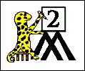Name Date

# NAME THE 3D SHAPES 1

Write the correct name for each shape using the list below.

|  |  |  |  |  |  |
| --- | --- | --- | --- | --- | --- |
| 1) |  | cube | 7) |  |  |
| 2) |  |  | 8) |  |  |
| 3) |  |  | 9) |  |  |
| 4) |  |  | 10) |  |  |
| 5) |  |  | 11) |  |  |
| 6) |  |  | 12) |  |  |