MADISON, Wisconsin. It's your turn to clean the bathroom—yuck. You've got lots of stuff to help you out. There's a cleaning solution that removes old soap from shower walls. There's cleaner to make the sink shiny and white. There's also something in a squeeze bottle that makes the toilet bowl sparkling clean. When you're all done, the room is clean. It's free of dirt and bacteria. There's just one problem. Those cleaning solutions you used can be harmful to people and the environment. For this reason, many people want traditional cleaners replaced. They want less harmful "green" products to be used instead.
What's wrong with some cleaning products? They contain harsh chemicals. These chemicals aren't healthy. They can harm humans, animals, and the planet. Think of the smoke coming from a factory and getting into the air. The smoke creates air pollution.This pollution harms the environment. It can make you feel ill when you breathe it in. Similarly, the chemicals in cleaning products pollute the air. They can hurt you if you breathe them in or they get on your skin.
Not all cleaning products are harmful. Green products do not contain harmful chemicals. They are good at cleaning. But they are also safe for people and for the planet. Still, not all products that say "green" or "all natural" are actually environmentally friendly. That is why the U.S. government's Environmental Protection Agency (EPA) has developed a label. This government group puts its label on products it considers to be safe. A group called Green Seal Inc. also tests products to determine which ones are safe. Linda Chipperfield is a vice president for Green Seal. Chipperfield says these products use less packaging. They do not contain chemicals that cause disease or kill anything that lives in lakes, streams, or oceans. They also do not harm the ozone layer. This layer protects the earth from the sun's rays. Like the EPA, Green Seal has developed a label for products that pass its testing.
Concern about chemicals has led many states to require schools and government buildings to use environmentally friendly cleaning products. As of early 2010, 10 states required or encouraged the use of green products. At least 5 other states were considering laws in support of these products.
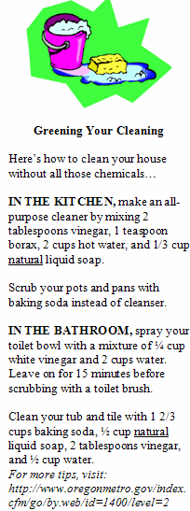
Wisconsin is one of those states. A bill there would apply to bathroom and floor cleaners. It would also apply to hand soap, toilet paper, paper towels, vacuum cleaners, and carpet cleaners. Among the law's supporters is a powerful group that represents public school teachers and workers.
"The goal of the bill is to make schools and other public space less toxic and healthier for kids and the general public," said Cory Mason, a Wisconsin lawmaker. He supports the bill.
Many green cleaning products are widely available. They cost about the same as traditional products. In some cases, manufacturers receive green labels for products they have long had on the market. The prices of these products remain low.
"There is no reason to pay a penny more to [buy] green products. Plain and simple," said John Matthews. Matthews is senior vice president for JohnsonDiversey. This company manufactures cleaning products. "And across the board, [good] companies [can make] green products that perform well."
But some green items can cost more than traditional products. Toilet paper, trash bags, and paper towels made from recycled materials can cost up to 20 percent more, said Stephen Ashkin. Ashkin is in charge of the Green Cleaning Network. This group supports the use of green cleaning products.
Opponents of Wisconsin's new bill are concerned about the possible higher costs for some green products. These people say that states should not determine which products schools and agencies must buy. This is especially true if the products cost more. Many schools and agencies don't have enough money, opponents point out.
Some states are trying to address concerns about costs. In Wisconsin, lawmakers made a change to the bill. Schools and agencies would now have three years instead of one to begin using green products. They would also be allowed to use products that are not green if they could show that their costs would increase.
The Associated Press contributed to this story.

