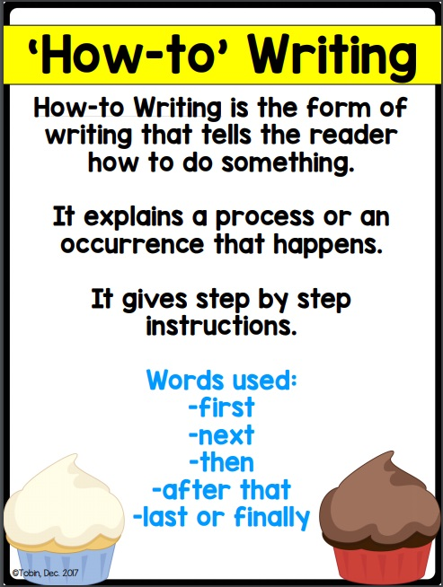
Planning Sheet

Introduction:

Step 1:

Step 2:

Step 3:

Step 4:

Closure:

TITLE:

(Begin writing here…)

