JOHN CABOT (1450?-1499)

John Cabot (known as Giovanni Caboto in Italy) was a great Italian navigator and explorer. He was probably born in Genoa, Italy around 1450, but he moved to Venice and that is where he most likely learned to sail.
In 1484, he moved again, this time to Bristol in England. That's when he decided to call himself John Cabot, the "English" version of his name. Like Columbus and others of his time, Cabot believed that Asia could be reached by sailing westward. Up until then, the only known way to get to Asia was by going east. Some wealthy Englishmen liked his ideas and paid for him to lead a westward expedition to Asia. They were anxious to find an easier and quicker way to bring back goods from Asia to trade in Europe.

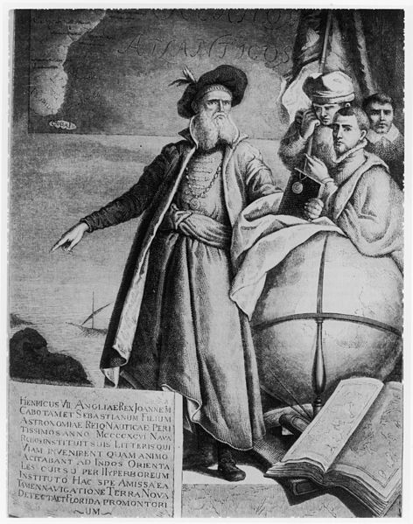
He made his first voyage to North America (which he thought was Asia) in 1497. The ship was called the Matthew and had a crew of 18 men. He sailed northwest, through the stormy Atlantic Ocean, and eventually came to North America. He sailed along the coast, past Labrador, Newfoundland, and New England. He claimed the land he found for England. King Henry VII was pleased with his efforts and granted Cabot a pension of 20 pounds a year.
In 1498, Cabot wanted to return to find "Japan," so he organized another expedition. This time, he took four or five ships and about 300 men and left Bristol in June of 1498. No one knows for certain what happened to this expedition, but it may have sailed from Greenland southward towards Chesapeake Bay in North America. Cabot had to return to England because he was running out of supplies, and he died soon after returning.

HERNÁN CORTÉS (1485-1547)
Hernán Cortés was a Spanish explorer who is famous mainly for his march across Mexico and his conquering of the Aztec Empire in Mexico.
Cortés was born in the Spanish city of Medellín in 1485. When he was a young man, he studied law, but he soon gave that up to seek his fortune in the New World that was just being discovered by Columbus and others.
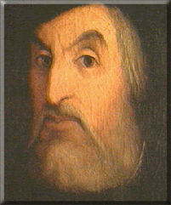
First he went to the island of Santo Domingo (now known as the Dominican Republic) in 1504. He was only 19 years old at the time. He stayed there for seven years, then took part in the Spanish conquest of Cuba in 1511. He became mayor of Santiago de Cuba and stayed there until 1518.
Cortés was eager for more power and conquests, so he talked the Spanish governor of Cuba into letting him lead an expedition to Mexico in 1519. Mexico had just been discovered by the Spanish explorer de Córdoba a year before.
At that time, Mexico was ruled by the Aztec Empire and its leader, Montezuma II. Cortés arrived in Mexico in March 1519 with a group of about 600 men and a few horses. He soon learned of the Aztecs and began to make his way inland to the Aztec capital city, Tenochtitlán. Along the way, he made friends with a native group called the Tlaxcalans, who were enemies of the Aztecs. The Tlaxcalans helped Cortés against the Aztecs.
In November of 1519, Cortés and his men reached the Aztec capital and met Montezuma. The Aztecs may have thought that Cortés was a god-king, and so they treated him and his soldiers well. However, Cortés was afraid that the Aztecs might soon try to get rid of him, so he took Montezuma hostage and asked for a huge ransom of gold and jewels.
It turned out that Cortés was right and the Aztecs finally drove him and his men out of their city in June of 1520. But Cortés regrouped and returned in the summer of 1521 to capture Tenochtitlán.
Soon after, he began to build Mexico City on the Aztec ruins and brought many Europeans over to live there. It soon became the most important European city in North America. Because of his conquests and all the gold and jewels he had collected, Cortés was very popular back home in Spain and so he was made governor and captain general of New Spain in 1523. But he wasn't done exploring.
In 1524, he led a group into Honduras and stayed in that area for two years. By 1528, the Spanish government was worried that Cortés was getting out of control in the Americas, and so he had to give up his governor's job and was sent back to Spain. He spoke to the king, who was persuaded to send Cortés back to Mexico in 1530, but with less power and freedom than before.
In 1536, Cortés explored the northwestern part of Mexico and discovered the Baja California peninsula. He also spent time exploring the Pacific coast of Mexico. This was the last major expedition by Cortés. In 1539, he went back to Spain, and spent much of the rest of his life there before he died near Seville in 1547.
Juan Ponce de Leon: Explorer
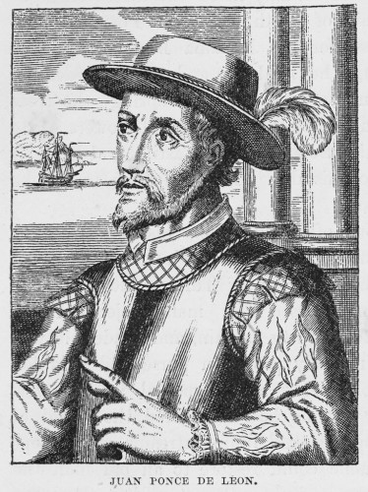
Juan Ponce de Leon (1460?-1521) was a Spanish explorer and soldier who was the first European to set foot in Florida. He also established the oldest European settlement in Puerto Rico and discovered the Gulf Stream (a current in the Atlantic Ocean). Ponce de Leon was searching for the legendary fountain of youth and other riches.
Born in Santervas, Spain, in 1460 (the date is uncertain), Ponce de Leon was a soldier fighting Muslims in southern Spain in the early 1490's. Ponce de Leon sailed on Christopher Columbus' second expedition to the Americas in 1493. Ponce de Leon did not return to Spain with Columbus; he stayed in Santo Domingo.
He was appointed governor of the Dominican province of Higuey. He later heard of gold in the neighboring island of Borinquen (now called Puerto Rico) and brutally conquered the island, claiming it for Spain. He was then appointed governor of this island, but due to his cruel treatment of Native Americans, he was demoted in 1511.
Ponce de Leon was then given the right to find and take the island of Bimini (in the Bahamas); he was searching for riches and the fountain of youth (a legendary spring that gave people eternal life and health). He sailed from Puerto Rico on March 3, 1513, with three ships, the Santa Maria, the Santiago, and the San Cristobal, and about 200 men. After stops at Grand Turk Island and San Salvador, they reached the east coast of Florida (St. Augustine) in April 1513. Ponce de Leon named the land "Pascua de Florida" (feast of flowers) because they first spotted land on April 2, 1513, Palm Sunday. He then claimed the land for Spain.
They left on April 8, heading south in the warm current now known as the Gulf Stream. This oceanic current would become very important for Spanish trips from Europe to America. On the return trip, a fight broke out between Ponce de Leon's men and Native Americans in southern Florida. They sailed to Cuba, then headed north, again trying to find Bimini (but instead, finding Andros Island).
After returning to Puerto Rico, Ponce de Leon resumed fighting with the Native Americans (putting down their rebellions against Spanish rule). He returned to Spain and was named a Captain General by the King of Spain on September 27, 1514, and again sailed to Puerto Rico to search for the elusive Bimini.
His last expedition was another search for Bimini in 1521. His force of 200 men landed on the west coast of Florida, but were met by Native American warriors, who wounded many of the men with arrows, including Ponce de Leon. Ponce de Leon later died in Havana, Cuba, from this wound (in July, 1521). He is buried in San Juan, Puerto Rico.

HENRY HUDSON (?-1611?)

Henry Hudson was a very good navigator and sailor who named and explored Hudson Bay in Canada and the Hudson River in America. His quest was to find a shortcut from Europe to the Far East. Hudson was from England, but nothing is known about his life before 1607.

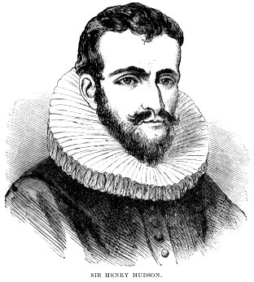
On May 1, 1607, Hudson, his son, and 11 other crew members sailed from England on the Hopewell. He and his crew went past Greenland toward the North Pole. They were working for an English trading company and were hoping to find a quicker way to get from England to the Far East, by way of the Arctic Ocean. In the next two years, he tried twice more to find a "northeast passage" but failed and returned to England. The trading company would not send him on any more explorations.
In 1609 he moved to Holland and sailed for a Dutch trading company on the ship named Half Moon. In 1609 he set sail from Amsterdam and headed north, again trying to find a way through the Arctic to the Far East. This time, conditions were so bad that his crew of about 20 men threatened to mutiny. Hudson turned the ship around and headed south down the east coast of Canada.

Hudson was hoping that the Atlantic and Pacific Oceans were separated by just a thin strip of land, and that he would be the one to find the shortest way between the two oceans. He sailed into New York Bay in September of 1609 and explored a river which became known as the Hudson River for about 150 miles. He was looking for the shortcut to the Pacific, but of course, he did not find it, so he returned to Holland. He was told by Holland to go back to England.
On his final journey from England in 1610, he again headed northwest towards Canada, this time on the ship Discovery. In August Hudson found a body of water which at first he thought was the Pacific Ocean. The body of water was a large bay, which eventually was named the Hudson Bay.
In November 1610, the Discovery became locked in ice in Hudson Bay. The crew wanted to get back to England, but Hudson would not let them leave. It was a very cold winter, and the crew suffered greatly in the icy conditions. The crew was thinking of mutiny. In June 1611, they decided to put Hudson, his son, and the seven others into a small boat, and they were never heard from again.
Francisco Vasquez de Coronado
Francisco Vasquez de Coronado was the Spanish Conquistador who explored the Southwestern part of the United States. Born in Spain in 1510, he went to Mexico City in 1535 where he married the daughter of Spain's Treasurer for Mexico. In 1538 he became a member of the town council and acting Governor of Nueva Gatina. He led his expedition into North America just after Cabeza de Vaca arrived in Mexico City with stories of riches to the north.
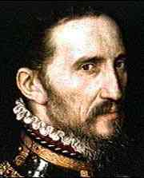
On February 22, 1540, Coronado's expedition, with 300 Spaniards and 1,000 Indians, began their march into the interior of this continent. Their trail led up the Gulf of California and crossed the White Mountains of Arizona. They conquered Cibola but with much disappointment. They did not find the gold which others had reported there.
Coronado moved his camp to the upper Rio Grande where his people killed more than 200 men, women and children in a massacre to pacify the area. In 1541 he led a party north, across Western Texas and Oklahoma, arriving at Quivira on the Arkansas River. He found only grass huts, not the opulent city of gold described by Cabeza de Vaca. In vain, he explored as far as central Kansas before returning to his people's camp then Mexico City.
He continued to serve as a city councilman despite the fact that he was crippled from a head injury he received during a jousting tournament in New Mexico. Coronado died in Mexico City in November, 1554.

Robert de La Salle
Robert de La Salle (1643-1687) was a French explorer. He was sent by King Louis XIV to travel south from Canada and sail down the Mississippi River to the Gulf of Mexico. He was the first European to travel the length of the Mississippi River. His mission was to explore and establish fur-trade routes along the river. La Salle named the entire Mississippi basin Louisiana, in honor of the King, and claimed it for France on April 9, 1682. He also explored Lake Michigan, Lake Huron, Lake Erie, and Lake Ontario. He tried to start a settlement in the southern Mississippi River Valley, but the venture ended in disaster.
La Salle traveled from France to Quebec, New France (Canada), in late 1667. He was determined to find a water passage to the east through North America. Leaving Montreal in July, 1669, La Salle crossed Lake Ontario, Lake Erie, and other places nearby. La Salle made many exploring trips during the years 1671 to 1673.
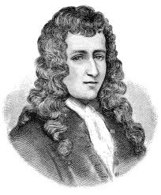
La Salle returned to France in 1677, getting permission from the King to explore the area between Florida, Mexico and Canada. In Canada, they constructed a fort on the Niagara River and built a ship called the Griffon, which they used to explore the Great Lakes. They sailed on August 7, 1679, traveling across Lake Erie and Lake Huron. They traveled across land to Lake Michigan, which they paddled across in canoes. Returning, they discovered that the Griffon was lost, the fort at Niagara had burned down, and many men had deserted their posts, robbing supply stores.
On a 1681 expedition, La Salle and about 40 men again headed to the Mississippi River. They reached the Mississippi River on February 6, 1682, then headed down it in canoes. They built Fort Prud'homme at what is now Memphis, Tennessee, and later reached the Gulf of Mexico on April 9, 1682, where they built a cross. They claimed all the land along the Mississippi River for France. Their return to New France was beset by illness and Indian attacks.
La Salle returned to France in 1683, and sailed to the New World again in 1684 with four ships, intending to start a colony in the Mississippi River Valley. The expedition lost a vital supply ship en route, and mistakenly landed in Matagorda Bay, near what is now Houston, Texas, where one ship ran aground. La Salle's men shot Indians who took supplies from the wrecked ship, making enemies of the local Indians. One ship returned to France with a disgruntled crew.
The French expedition built a fort at the mouth of the Lavaca River, and explored the area. The last remaining ship was wrecked in April 1686, stranding the French in Texas. The 20 men traveled up the Lavaca River, trying to locate the Mississippi River so they could follow it north into the French missions in the Great Lakes region. Most of the men in this expedition died, and the 8 survivors returned to the fort in October, 1686. On a second try, La Salle and 17 others set out; in a few months, a group of five mutineers shot and killed La Salle on March 19, 1687.

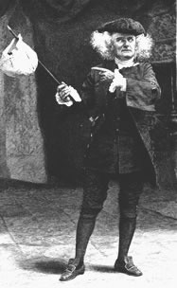
Jacques Cartier

Born in Saint-Malo, France on December 31, 1491, Jacques Cartier reportedly explored the Americas, particularly Brazil, before making three major North American voyages. In 1534, King Francis I of France sent Cartier—likely because of his previous expeditions—on a new trip to the eastern coast of North America, then called the "northern lands." On a voyage that would add him to the list of famous explorers, Cartier was to search for gold and other riches, spices, and a passage to Asia.
Cartier sailed on April 20, 1534, with two ships and 61 men, and arrived 20 days later. He explored the west coast of Newfoundland, discovered Prince Edward Island and sailed through the Gulf of St. Lawrence, past Anticosti Island.
Upon returning to France, King Francis was impressed with Cartier’s report of what he had seen, so he sent the explorer back the following year, in May, with three ships and 110 men. Two Indians Cartier had captured previously now served as guides, and he and his men navigated the St. Lawrence, as far as Quebec, and established a base.
In September, Cartier sailed downriver to what would become Montreal and was welcomed by the Iroquois who controlled the area, hearing from them that there were other rivers that led farther west, where gold, silver, copper and spices could be found. Before they could continue, though, the harsh winter blew in, rapids made the river impassable, and Cartier and his men managed to anger the Iroquois.
So Cartier waited until spring, when the river was free of ice, and captured some of the Iroquois chiefs before again returning to France. Because of his hasty escape, Cartier was only able to report to the king that untold riches lay farther west and that a great river, said to be about 2,000 miles long, possibly led to Asia.
In May of 1541, Cartier departed on his third voyage with five ships. He had by now abandoned the idea of finding a passage to the Orient, and was sent to establish a permanent settlement along the St. Lawrence River on behalf of France. A group of colonists was a few months behind him this time.
Cartier set up camp again near Quebec, and they found an abundance of what they thought were gold and diamonds. In the spring, not waiting for the colonists to arrive, Cartier abandoned the base and sailed for France. En route, he stopped at Newfoundland, where he encountered the colonists, whose leader ordered Cartier back to Quebec. Cartier, however, had other plans; instead of heading to Quebec, he sneaked away during the night and returned to France.
There, his "gold" and "diamonds" were found to be worthless, and the colonists abandoned plans to found a settlement, returning to France after experiencing their first bitter winter. After these setbacks, France didn’t show any interest in these new lands for half a century, and Cartier’s career as a state-funded explorer came to an end. His exploration of the St. Lawrence River allowed France to lay claim to lands that would become Canada. He died in Saint-Malo in 1557.

