- Name:
- Class:
- Date:

RL.1.2 – Classwork
How Thunder and Lightning Came
A North American Indian Story
retold by Gretchen Will Mayo
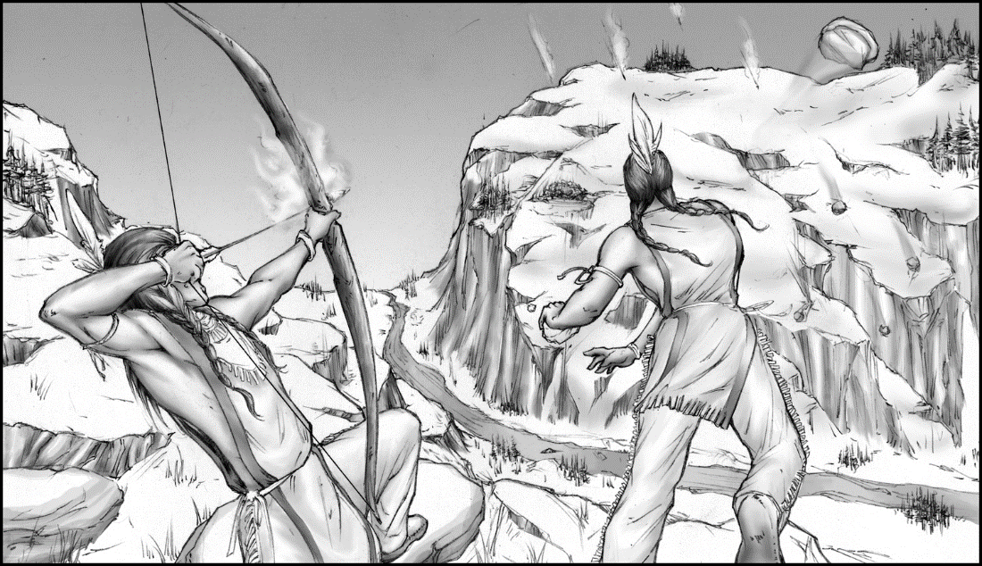
1 | Enumclaw and Kapoonis were brothers who were fine hunters but wanted to become something more. These two brothers were often away from the village for many moons, hunting wild game, drying the meat, and hiding it to use later. But their travels had another purpose because each searched for a guardian spirit that would make him a great medicine man.

2 | Kapoonis tried to find his guardian spirit in a vision. Every morning and every night he took baths in the river so he might be worthy of a powerful vision. That’s how he found a fire spirit so powerful that he was able to throw flames from one bank of the river to the other.

3 | Meanwhile Enumclaw grew strong too. In the mountains he practiced tossing stones from one peak to another, making sharp cracking sounds. Sometimes he threw the stones against rocks to call his younger brother or send him signals. Each day Enumclaw threw larger stones. Each day the cracks grew louder.

4 | When he saw people crossing the mountains, Enumclaw threw rocks at the nearby peaks warning his brother that someone was near. But now the terrible noise hurt the ears of the people and made them run home. “Enumclaw frightens the largest birds and makes them fly so fast their wings make loud rumbles!” cried the people. “And Kapoonis throws arrows of fire from peak to peak!”

5 | Enumclaw and Kapoonis did not know the people were frightened. To them, it was a game to test their power.

6 | One night the two brothers sat on a rocky ridge facing the setting sun. “Look Kapoonis,” said his brother. “There is a great white rock across the river. I will throw stones on the left side of the rock so hard that the ridge along the river will fall.”

7 | “Sounds like fun!” said Kapoonis. “I’ll flash my bolts of fire to the right.”

8 | Enumclaw threw his stones as hard as he could, and Kapoonis hurled out great bolts of flame, igniting the sky and sending the people to hide and cover their ears. Afterwards, there was nothing left of the ridge along the river.

9 | From above the peaks, the Great Spirit watched the brothers playing their games and wrecking the land. “It is too dangerous for humans to have so much power,” said the Great Spirit. So he made Enumclaw and Kapoonis thunder and lightning and gave them a new home far above the people.
Told by Henry Sicade to Herman Haeberlin and originally published in the TACOMA EVENING NEWS in 1916.
Question #1
How does the story end?
- The Great Spirit scolds Kapoonis and Enumclaw.
- Enumclaw and Kapoonis become friends.
- The Great Spirit moves Kapoonis and Enumclaw to the sky.
- Enumclaw and Kapoonis become wild game hunters.

Question #2
What lesson can be learned from reading the story?
- Each person has unique talents to offer.
- Games are useful for learning skills.
- Always be honest with your friends.
- Power can be harmful when it is in the wrong hands.

Question #3
What is the main reason the Great Spirit gives Enumclaw and Kapoonis a new home far above the people?
- They scare the animals.
- They are too dangerous.
- They have too much fun.
- They frighten the people.

Question #4
How does the Great Spirit solve the problem of Enumclaw and Kapoonis having too much power?
- The Great Spirit makes Enumclaw and Kapoonis hide in the mountains.
- The Great Spirit changes Enumclaw and Kapoonis into thunder and lightning.
- The Great Spirit throws stones at Enumclaw while throwing lightning at Kapoonis.
- The Great Spirit frightens Enumclaw and Kapoonis by making the large birds fly fast.

Question #5
The purpose of this story is to describe
- the friendship between two brothers.
- how a famous place got its name.
- what life was like long ago.
- how certain nature events came to be.

