BAGS BANNED

By Brian S. McGrath

New York State has banned single-use plastic bags. The  
new law went into effect on March 1. New York is one of several states to forbid stores from handing out plastic bags at checkout. California was the first. Many cities and counties in the United States already have similar laws.

Andrew Cuomo is New York’s governor. He proposed the  
ban last year. “For far too long, these bags have blighted our environment and clogged our waterways,” he said.

Officials say the ban will change people’s shopping habits. Until now, New Yorkers used  
23 billion plastic bags each  
year. The bags are harmful to birds and marine animals. The

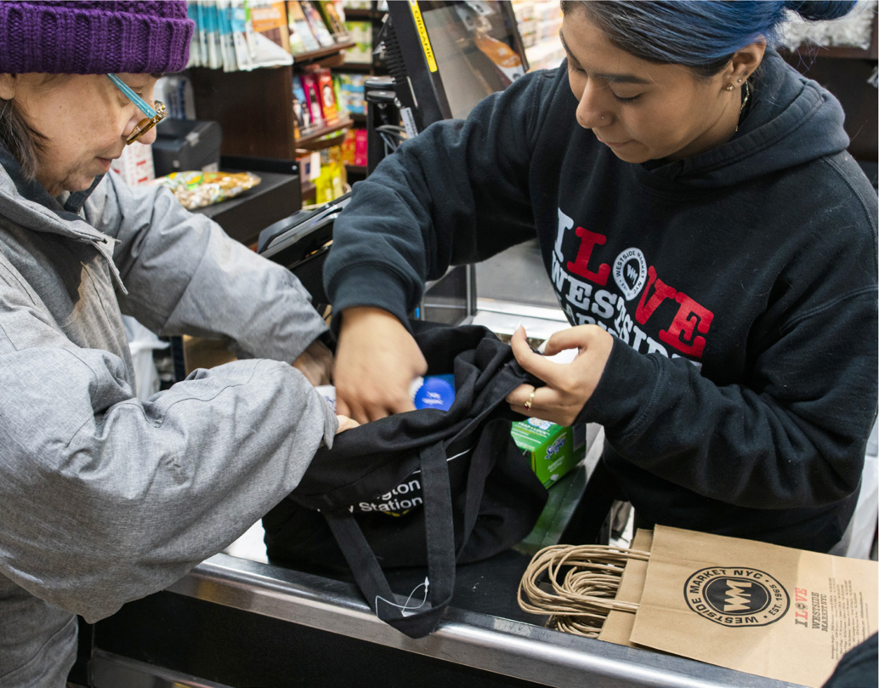page1image1282328160

REUSE IT A store  
clerk helps a  
customer pack  
a reusable bag in  
New York City, where a ban on plastic bags is in effect.

U.S. Environmental Protection Agency says some communities spend $1 million each year cleaning up litter. Much of it is grocery bags.

Businesses could pay up to $500 each time for breaking the law. Paper bags are allowed. But they may cost shoppers 5¢ each.

New York State leaders say people should keep reusable

community. One of them will be named the TIME Kid of the Year.

Trevor Noah will be the show’s host. He’s a comedian and an author. Noah says the TV special “celebrates everything that makes young people amazing, and gives them a platform to have their voices heard.”

Do you know someone  
who should be the TIME Kid  
of the Year? We’ll be asking readers for their nominations soon. Keep an

bags in their car or backpack. Small purchases may not need a bag at all.

Stop and Think!

WHY might news about a law in one state be of interest to people across the country? Could such a story influence other states to pass a similar law? Why or why not?

Your answer can start like this:

\*\*\*News and information about a law in another state may be of interest to people in other parts of the country because……\*\*\*\*

STAY TUNED Trevor Noah announces the Kid of the Year TV special.