Energy Control
by Sharon Guynup

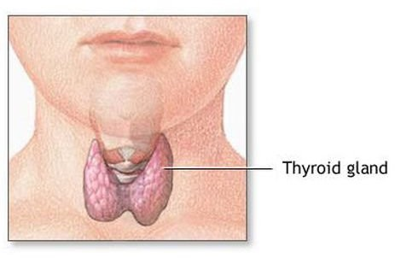

Your thyroid powers your body.
Do you like to shoot hoops or swim? Without the help of your thyroid, you wouldn't have the energy to compete-or to get off the couch. Your thyroid is a 1-ounce gland that controls the speed of your heartbeat, the speed with which your body burns calories, and the growth of your bones, teeth, and brain. The pinkish, butterfly-shaped gland wraps around the windpipe in front of the throat. It affects nearly every organ in your body.

The thyroid is your body's factory for a hormone, or body chemical, called thyroxine. The thyroid secretes this chemical into your bloodstream, which is your body's superhighway. The bloodstream delivers the chemical's message to your cells: Get to work! Thyroxine controls your body's metabolism. That means it sets the pace for how quickly cells transform food into energy. The hormone also affects the speed of many chemical reactions in your body.

The thyroid is one of many endocrine glands that control body functions. The glands are part of a system that regulates hormones. When the thyroid springs into action, the original work order comes from your brain. From atop your brain stem, an organ called the hypothalamus keeps tabs on hormone levels in your body-about 200 in all. When thyroxine levels drop too low, the hypothalamus sends off a warning to its neighbor, the pituitary gland. That pea-sized "master gland" kicks the thyroid into production-and kicks you into gear.

Pay attention to your body: Diseases of the thyroid are common. These problems affect millions of Americans. An overactive thyroid (hyperthyroidism) can affect a person's heart and make the person skinny and nervous. People with an underactive thyroid (hypothyroidism) feel exhausted, gain weight,

and are often cold.

Pollution may cause thyroid disease. Some industrial chemicals are absorbed by the body through air, water, or food. Those substances can disrupt the body's hormone balance. Toxins from smoking cigarettes or chewing tobacco can damage the thyroid too.

The good news: There are treatments for some thyroid conditions. If you are like most people, your body's energy control system keeps everything in balance so that you're raring to go!

Thyroid
Alias: Butterfly gland

Mission: Controls heart rate, metabolism, and growth of bones, teeth, and brain

Power: Speeds work of organs and chemical reactions

Weaknesses: Damaged by pollution, which disrupts hormone balance; hurt by radiation, which can cause cancer; harmed by tobacco use, which may triple the threat of thyroid disease

Upgrades: Iodine in food and salt keeps the thyroid in running order.

Maintenance: Watch for symptoms of an underactive thyroid (hypothyroidism), such as sluggishness, weight gain, and a constant feeling of cold. Look for symptoms of an overactive thyroid (hyperthyroidism), such as weight loss and nervousness. Do not smoke or chew tobacco.

Name: Date:

Your thyroid gland plays an important part in all of the following EXCEPT
  - how energetic or tired you feel
  - how fast you can run
  - how quickly your heart beats
  - the rate at which your body converts food into energy

- Read these sentences from the passage:

"The thyroid is one of many endocrine glands that control body functions. The glands are part of a system that regulates hormones."
Which of the following describes the relationship between the first sentence and the second sentence?
  - The sentences make comparisons about the thyroid.
  - The second sentence adds information to the description in the first sentence.
  - The first and second sentences describe steps in a sequence.
  - The first sentence names a cause, and the second sentence describes an effect.

- Why might an overactive thyroid make a person skinny?
  - It could make the person feel sleepy and less energetic.
  - It could make the person want to do more exercise.
  - It could make the person's body absorb calories more quickly.
  - It could help the person eat less fattening foods.

- Read the following sentence:

"The thyroid secretes this chemical into your bloodstream, which is your body's superhighway."

In this sentence the word secretes means
  - cleans
  - removes
  - delivers
  - hides

- The main purpose of this passage is to
  - provide a list of hormones and explain what each one does
  - describe the thyroid and explain how it works
  - persuade young people to eat better and exercise more
  - compare and contrast the thyroid with the pituitary gland

- The question below is an incomplete sentence. Choose the word that best completes the sentence.

the pituitary gland is only the size of a pea, it can push the thyroid into production, which is why it is called the "master gland."
  - Because
  - Although
  - First
  - Overall

