REVIEW WEEKS 17–23 /
SHOW WHAT YOU KNOW
THIRD QUARTER
WEEK 24

Let’s
Review...

Patriots
- Globes and Maps
- Cultures
- American Symbols
- Inventors and Inventions

www.s-w.co/FL2-24

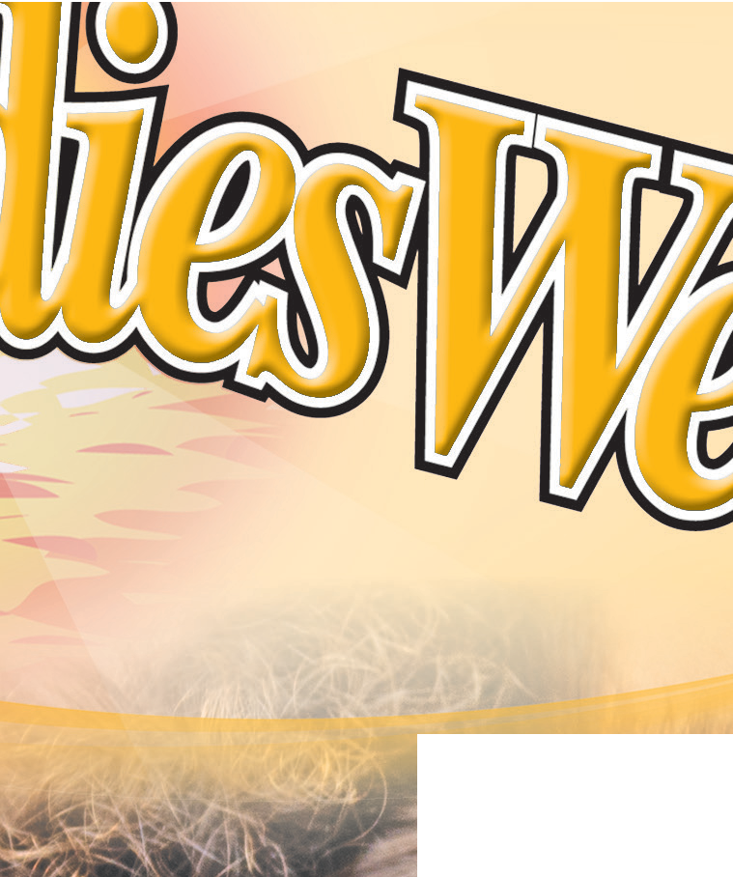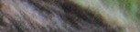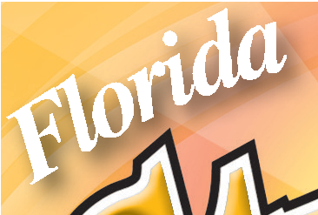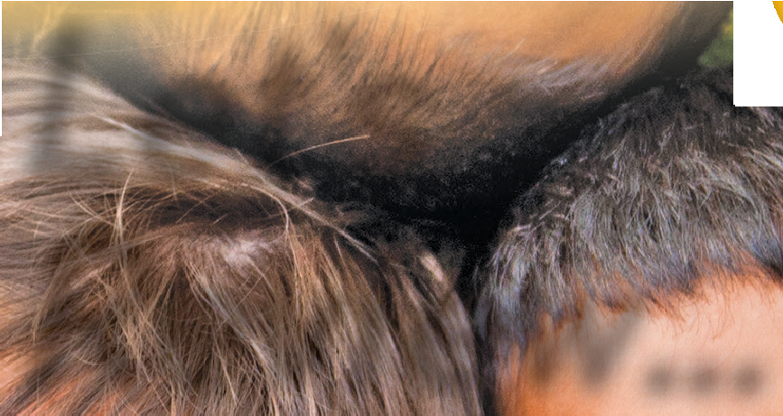

You can find many different cultures in Florida. Long ago, only American Indians lived in Florida. Today, many different people from many different places live here. What is something that makes your culture special?

Florida Next Generation Sunshine State Standards: SS.2.A.1.1: Examine primary and secondary sources. SS.2.A.1.2: Utilize the media center, technology or other informational sources to locate information that provides answers to questions about a historical topic. SS.2.A.2.1: Recognize
that American Indians were the first inhabitants in North America. SS.2.C.2.4: Identify ways citizens can make a positive contribution in their community. SS.2.C.2.5: Evaluate the contributions of various African Americans, Hispanics, American Indians, veterans and women. SS.2.G.1.1: Use different types of maps (political, physical and thematic) to identify map elements. SS.2.G.1.3: Label on a map or globe the continents, oceans, Equator, Prime Meridian, North and South Pole.

Let’s Review...
SHOW WHAT YOU KNOW Florida Studies Weekly Second Grade

Many cultures celebrate different winter holidays. Draw a line to match the holiday with the culture that celebrates it.

Asian Americans Las Posadas
Hispanic Americans Kwanzaa
African Americans Dong Zhi

Match the patriot to his or her description. Draw a line to connect them.

Label the equator and prime meridian.

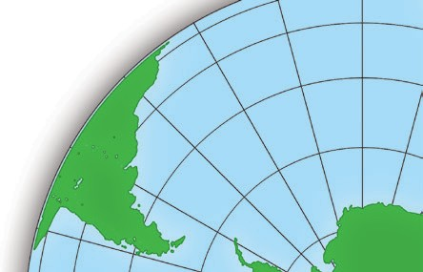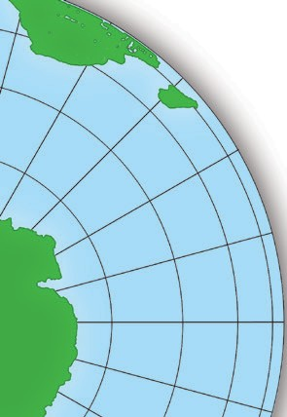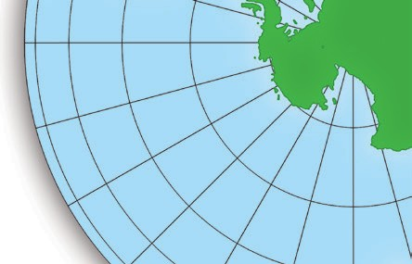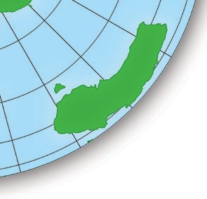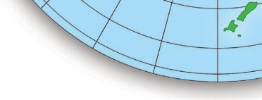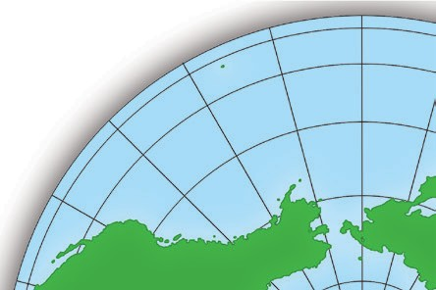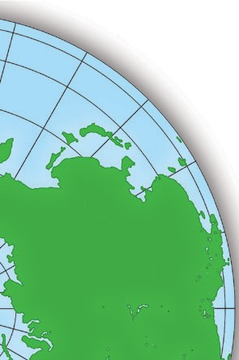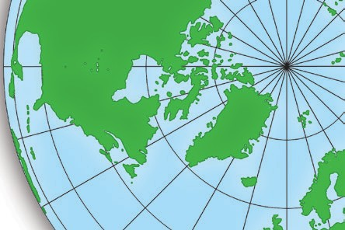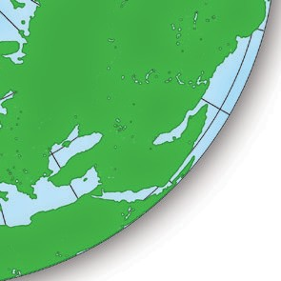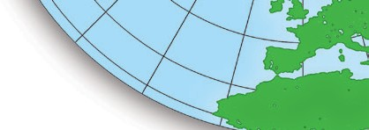Label the North and South Poles.

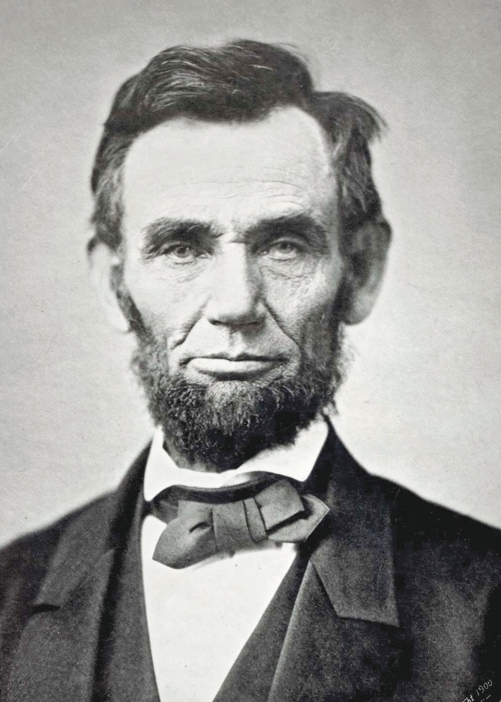
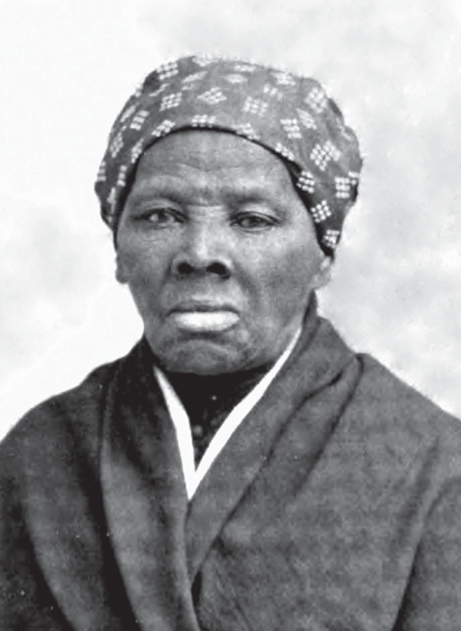
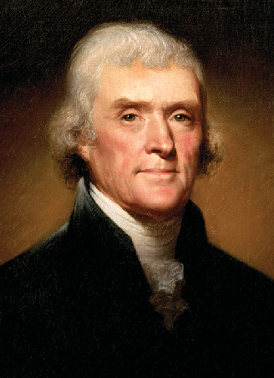
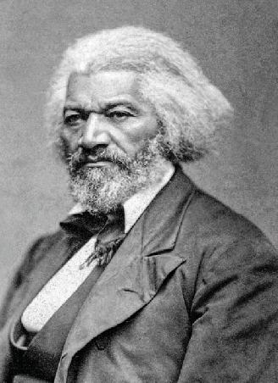
Frederick Douglass
Thomas Jefferson
Abraham Lincoln
Harriet Tubman

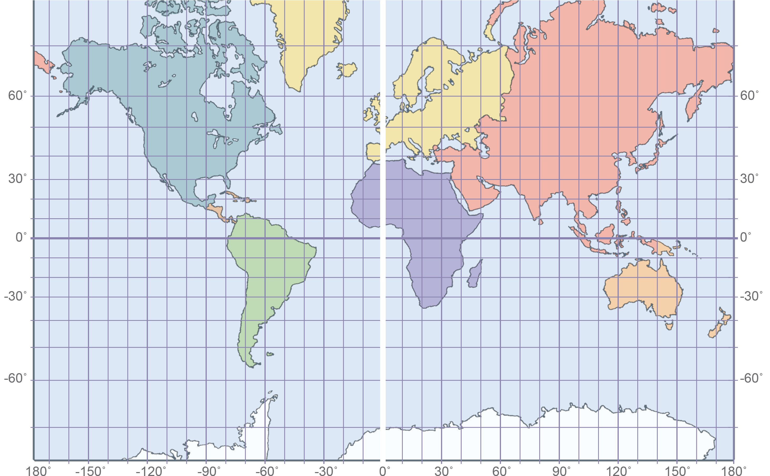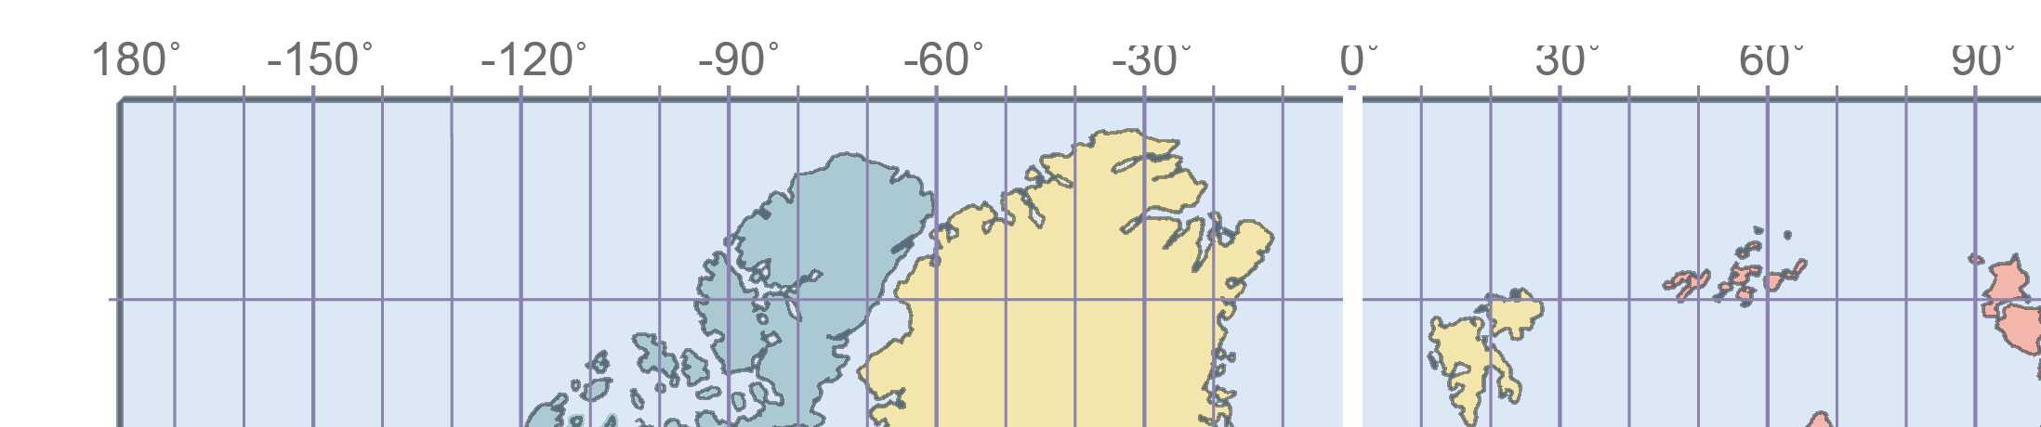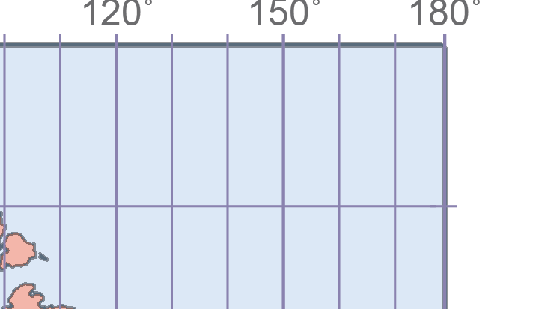
born in Maryland and helped slaves escape to the north

Page 2

born in Kentucky and ended slavery while he was president of the United States

born into slavery and started
the newspaper called “The North Star”

our third president and writer of the Declaration of Independence
What are some symbols that we use to celebrate America? Draw a symbol in the box.

Page 3

Name

Read how technology has changed our lives. Which inventor made it possible? Which invention did he create? Draw lines to match the improvement, inventor and invention.

Improvement
This invention changed how we communicate.

This invention changed how we travel.

This invention changed how we see at night.
Inventor
Thomas Edison

Alexander Graham Bell

Orville and Wilbur Wright

What is school like for you? What is it like for children around the world? Write the words from the box in your diagram.

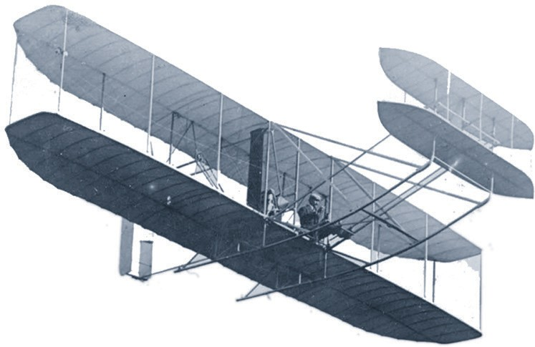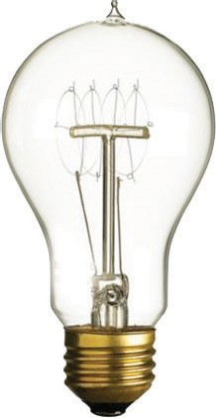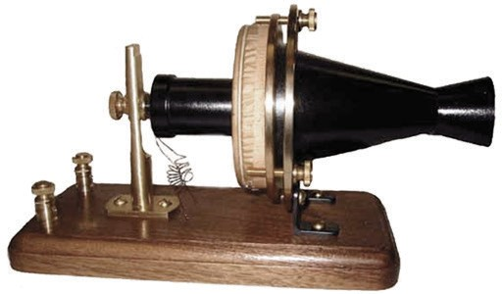Word Bank
- sweep the floor
- do exercises before class
- bring coconuts
- ride the bus
- read

Page 4

My School

Both
Schools Around the World

