Seconds from Winning
By Gordon McAlpine and Illustrated by Gary Undercuffler
- Paxton won't be satisfied with second place in the go-kart race today...but can he beat Mark, who has more sponsors and a better kart?

- Paxton pushed his foot down hard on the gas pedal as he steered his go-kart out of turn six and onto the racetrack's long straightaway. Even with his crash helmet and earplugs, the roar of the engine was loud. Paxton loved the sound. At the speed he was going, spectators watching the race flashed by as fast as thoughts. Nothing beats racing.
- Paxton hadn't come from a "racing family," and he had no sponsors for his kart. But with the help of his uncle Bobby, who worked as a mechanic at the local repair shop, Paxton's kart was fast enough to compete.
- On the long straightaway, Paxton pulled alongside the race's leader, Mark, who so far had stayed just out of Paxton's reach.
- Only five laps to go. Paxton glanced over. Mark had so many sponsors that his go-kart looked like a rolling billboard. Mark turned, and for a moment his eyes met Paxton's. Both boys wanted to win. No other karts were close to the two leaders.
- Paxton returned his attention to the road and pressed harder on the gas, but his go-kart was already at top speed. Mark's kart pulled away. Paxton had no choice but to fall in behind him as they slowed to go into the next turn.
- A moment later, the boys roared past the pits. Uncle Bobby gave Paxton a thumbs-up and held a sign that said "Go Get Him!" Paxton had never finished higher than fifth in a race. Still, he wasn't going to be satisfied with second place today. The winner would get tickets to the pro championship race - presented by two-time champion L.J. Richards!
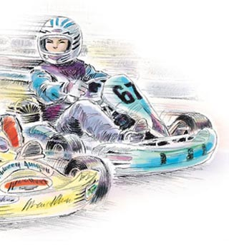
- Mark pulled farther ahead of Paxton as they entered the S curves - a series of quick right and left turns. Paxton's kart fishtailed as he came out of the last short turn. He'd almost lost control. But Paxton wasn't ready to give up. He concentrated as he made a long right-hand turn, then accelerated onto the straightaway, his foot pressed hard against the pedal. Still, the engine on Mark's kart was too powerful, and Mark pulled away.
- In the curves, Paxton would catch up, sometimes almost tapping the back end of Mark's kart. But in the straightaways, he'd fall behind.
- Meanwhile, the laps counted off: four to go, three to go, two to go, one to go.

- On the last turn, Paxton drew directly behind Mark. As they rounded out of the turn and onto the final straightaway, Paxton floored it. He pulled beside Mark's kart. Their engines screamed. Then, as it had so many times before, Mark's kart pulled ahead. The finish line was zooming toward them. Closer, closer….
- The race was over. It was not Paxton who would hoist the winner's trophy. Paxton had come in second. As Paxton pulled into the pits, his vision blurred with tears.
- "Good race, Paxton," Uncle Bobby said, helping him climb out of the kart.
- Paxton flipped up the visor on his helmet. "Thanks, but I didn't win, Uncle Bobby.” Nothing could alter the fact that he’d crossed the finish line looking at the back of Mark's kart, not at a checkered flag. Good race? He remembered what other drivers had sometimes said, "Second place is just first loser."
- "Great work, kid," said a man's voice.
- Paxton turned. He couldn't believe it. The man was L.J. Richards! L.J. Richards reached out to shake Paxton's hand.
- "Thank you, Mr. Richards. But I only came in second." Paxton looked around, wondering if the great driver had mistaken him for Mark, who was now jumping up and down in celebration on pit row. Paxton pointed in Mark's direction. "You're probably looking for him, Mr. Richards."
- "Oh, I'll get there." L.J. Richards shrugged. "Every race has a winner, Paxton. But that's not the only thing racing is about." Paxton was surprised to hear such words from a two-time champion.
- "Getting 100 percent out of your kart is the most important thing," L.J. Richards said. "And to do that, you have to get 100 percent out of yourself. That's what it's all about."
- Paxton nodded.
- L.J. Richards continued, "And today, you gave 100 percent.”

- Paxton thought about this. Had he done the best he could do?
- After a moment, he smiled. "Yeah, I guess I did."

Reprinted with permission by Highlights for Children, Inc.

Answer questions number 1-8. Base your answers on the passage “Seconds from Winning.”
- Part A
How does Mr. Richards’ react to Paxton losing the race?

- He is angry Paxton had been unable to win.
- He is disappointed Paxton came in second place.
- He is satisfied Paxton tried his best the entire race.
- He is excited Paxton can still go to the championship race.

- Part B
Select a statement made by Mr. Richards to support your answer to Part A.

- "Oh, I'll get there." (paragraph 18)
- “Every race has a winner, Paxton.” (paragraph 18)
- “That's what it's all about." (paragraph 19)
- "And today, you gave 100 percent.” (paragraph 21)

Read paragraph 2 from the passage.

Paxton pushed his foot down hard on the gas pedal as he steered his go-kart out of turn six and onto the racetrack's long straightaway. Even with his crash helmet and earplugs, the roar of the engine was loud. Paxton loved the sound. At the speed he was going, spectators watching the race flashed by as fast as thoughts. Nothing beats racing.

How does the italicized sentence help convey the tone of the paragraph?

- It proves that go-kart racing is a difficult sport.
- It shows the character believes racing is popular.
- It demonstrates the importance of the go-kart racing.
- It emphasizes that the character feels racing is the best sport.

- Read this sentence from the passage.

Mark had so many sponsors that his go-kart looked like a rolling billboard.

If the root word spons- means “promising support”, what does sponsor mean?

- having a lack of support
- receiving support again
- unable to receive support
- a person who provides support

- Read these sentences from paragraph 2.

Even with his crash helmet and earplugs, the roar of the engine was loud. Paxton loved the sound. At the speed he was going, spectators watching the race flashed by as fast as thoughts.

Select the meaning of the word spectators as it is used in the sentences above.

- audience
- bleachers
- cameras
- drivers

- Select the statement with which the narrator would most likely agree.

- Go-kart racing is a tough sport to win.
- It is important to always give your best effort.
- Second place is not as rewarding as first place.
- Winning is everything, no matter what the cost.

- Select two details from the passage that best demonstrate Uncle Bobby is supportive of Paxton.

- Uncle Bobby buys Paxton tickets to a big race.
- Uncle Bobby helps Paxton build a fast go-kart.
- Uncle Bobby finds Paxton sponsors for his go-kart.
- Uncle Bobby allows Paxton to work in his repair shop.
- Uncle Bobby gives Paxton a thumbs-up during the race.

- Select the sentence below that is written with correct grammar, punctuation, capitalization, usage, and spelling.

- The go-kart driver turned the corner to quickly and fliped over into the grass.
- The go-kart driver turnt the corner to quickly and flipped over in to the grass.
- The go-kart driver turned the corner too quickly and flipped over into the grass.
- The go-kart driver turnded the corner too quickly and fliped over in to the grass.

First a Page, Then a Knight
- The time in history between 500 A.D. and 1500 A.D. was called the Age of Knights. Knights were soldiers who protected their lords and castles by living according to a very strict code. They had many duties and were known for displaying honor. Knights had to learn so many things, that a boy’s training would begin at a very early age and took many, many years.

- Around the age of 6 or 7, a young boy was taken by his father to live at a nearby castle. During his time at the castle, the boy was known as a page. Being a page was the first part of training to become a knight. A page received most of his training from the lord of the castle, who was already a knight. The lord and his family owned and lived in the castle.

- A page had to learn and master a variety of jobs. During this time in history, hunting was very important. The young page would learn how to ride a horse and use a bow and arrow. He learned how to handle hawks and falcons, birds trained for hunting. He took care of the hunting dogs. Cleaning the knight’s suit of armor was also the page’s job. Armor protected the knight when he was in battle. The armor was made of many pieces of metal and sometimes weighed sixty pounds, making it difficult to properly clean. Dirty armor was unacceptable!

- But the life of a page was not all work. There was also time for fun. The pages living in the castle with the knight’s family enjoyed playing games like checkers together. Pages also loved to hear the knight tell stories of his many adventures.

- A page eagerly looked forward to becoming a teenager. Between the ages of 13 and 15, a boy began his training as a squire. As a squire, he would begin the next part of his training to become a knight.

- The duties and education of a squire were very different from those of a page. Leaving behind the bow and arrow, the squire now learned to use a sword and shield. The squire learned how to care for the knight’s horse. As the squire grew older and stronger, he rode with the knight into battle. He carried extra weapons. He wore armor just like the knight, except he wore silver spurs while the knight wore golden spurs. If his knight was injured in battle, it was the squire’s duty to protect him. By the time the squire was 19 or 20 years old, he was actually a knight-in-training.

- Not all squires became knights. The squire could only become a knight if the lord of the castle believed he was qualified. Many guests would be invited to the castle for the knighting ceremony. After a grand feast, the squire would kneel before the lord. The lord would tap the young squire on the shoulder with a sword and say, “I dub thee Sir Knight.” The new knight then received his own sword and golden spurs.

- Finally, after years of hard work and training, the young squire had become a knight!
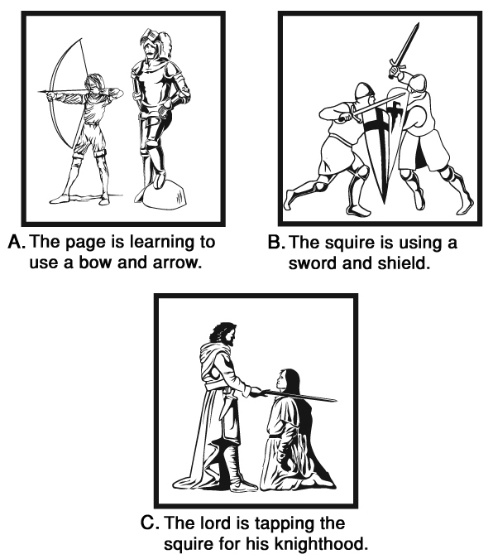

Answer questions number 9-16. Base your answers on the passage “First a Page, then a Knight.”
- Part A
Read these sentences from the passage.

A page had to learn and master a variety of jobs. During this time in history, hunting was very important.

What does the word master mean as used in the sentences above?

- to share ideas
- to assist others
- to become skilled
- to provide directions

- Part B
Read these sentences from the passage.

A page had to learn and master a variety of jobs. During this time in history, hunting was very important.

Using your answer to Part A, select the context clue best used to define the word master.

- learn
- variety
- history
- hunting

- Select the statement that best summarizes the two main ideas in the passage.

- A boy wanting to become a knight must learn the duties of a page, then become a skilled squire.
- A page wanting to become a squire must be trained to use a sword, then work with a knight to plan a feast.
- A knight wanting to become a lord must teach a page to care for horses, then find a squire to protect him.
- A father wanting his son to become a knight must find a lord of a castle, then teach him the steps to hunt.

- The following table shows the steps to become a knight. The steps are placed in the order in which they occur.

1. A father takes his son to a castle to become a page.
2. A page learns how to clean a knight’s armor
3.
4. A squire learns how to use a sword and a shield.
5. A knight receives a sword and golden spurs.

Select the event that best completes the table above.

- A squire attends a grand feast.
- A squire plays checkers with his family.
- A page is taught to use a bow and arrow.
- A page kneels before the lord or the castle.

- Select two sentences from the passage that demonstrate that the life of a page was not all work.

- Being a page was the first part of training to become a knight. (paragraph 2)
- He learned how to handle hawks and falcons, birds trained for hunting. (paragraph 3)
- He took care of the hunting dogs. (paragraph 3)
- The pages living in the castle enjoyed playing games and checkers together. (paragraph 4)
- Pages also loved to hear the knight tell stories of his many adventures. (paragraph 4)

- Read paragraph 7 from the passage.

Not all squires became knights. The squire could only become a knight if the lord of the castle believed he was qualified. Many guests would be invited to the castle for the knighting ceremony. After a grand feast, the squire would kneel before the lord. The lord would tap the young squire on the shoulder with a sword and say, “I dub thee Sir Knight.” The new knight then received his own sword and golden spurs.
Select a sentence from the paragraph that supports the idea some squires were unable to become knights.

- The squire could only become a knight if the lord of the castle believed he was qualified.
- Many guests would be invited to the castle for the knighting ceremony.
- After a grand feast, the squire would kneel before the lord.
- The new knight then received his own sword and golden spurs.

- Select the pair of words from the passage that is most opposite in meaning.

- owned, lived
- protect, attack
- knight, ceremony
- qualified, received

- Select the sentence below that is written with correct grammar, punctuation, capitalization, usage, and spelling.

- A page is responseble for making sure the knights’ horse was clean and had fresh water.
- A page be responseible for making sure the knights’ horse was clean and had fresh water.
- A page was responsible for making sure the knight’s horse was clean and had fresh water.
- A page were responsable for making sure the knight’s horse was clean, and had fresh water.

My Stinky Summer Vacation
By Lori Anastasia and Illustrated by Marcelo Baez

- It was the year 2058. Anna spent her summer helping her grandfather turn cow manure into fuel, to help save the planet. But will she be too embarrassed to tell her new fifth grade class about her summer?
- I chewed on my pencil as I paced back and forth across my bedroom. What was I going to do? It was bad enough that I was the new kid. But now I was sure to get laughed right out of fifth grade. How could my first homework assignment be such a disaster?
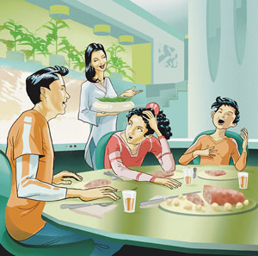
- I sat at my desk and stared at the computer screen. "My name is Anna Kincaid, and this summer I…” Then I stopped. I had no idea how I could stand in front of my class and say that I'd spent the entire summer handling something that most people don't even like to talk about. Manure. Otherwise known as poop. I'd spent three months shoveling, collecting, and analyzing cow manure on my grandparents' farm in Oklahoma. I tried to think of a different adventure I could share. Maybe I could say I'd spent the summer on the Weather Control Team preventing tornadoes in the Midwest.
- "Time for dinner," my mom called.

- I dragged my feet as I slowly trudged down the stairs and slid into my chair.
- "You've been in your room since you got home from school," Mom said. "What are you working on?"
- I groaned. "I have to tell the class what I did this summer.”
- My younger brother, Seymour, started giggling uncontrollably. "No one will want to sit next to you after they hear you were covered in cow poop all summer!"
- "OK, that's enough, Seymour," Dad said.

- "Anna," said Mom, putting green beans in a bowl, "be proud of the work we did this summer. Our planet would be in sad shape without scientists like your grandfather."
- It's true that my grandfather does important work. Back in 2017, he developed an easy way to use manure as a source of fuel, and he's spent the last couple of decades perfecting the method. Using the manure is now easy, economical, and environmentally safe.
- "I know, Mom," I said, staring at my meatloaf. "But it's not exactly something people want to hear about before lunch."
- "Or during dinner," Dad said, chuckling as he also studied his meatloaf.
- That night I dreamed about more glamorous adventures: scuba diving in Australia as I restored the Great Barrier Reef; swinging from vines as I protected the rain forests in Brazil. I tossed and turned.
- At school the next day, I hunched over my desk, listening to each kid speak. My palms were sweaty, and the knot in my stomach grew tighter. I prepared myself for total humiliation.
- "And that was my voyage to the moon's first Lunar Hotel and Day Spa," Ember Adams said, finishing her report. She bowed and took her seat.
- "It's your turn, Anna," Ms. Hammond said.
- I breathed quickly. Clutching my micro-mobile computer, I stepped to the front of the room and cleared my throat. "This summer I - well, I . . ." I stared at the floor.
- This was my last chance to save my dignity with a tale of fake adventure.
- Then I thought about Grandpa and how hard he works to save our planet. "I spent the summer collecting cow manure," I blurted. I looked around the room. No one seemed completely disgusted, although there were some confused faces.
- I hit a few keys on my computer, and a three-dimensional image of a cow eating alfalfa appeared in the middle of the classroom. I proceeded to take my classmates on a virtual tour that started with the cow in the pasture and ended with a man fueling his car at the local methane-gas pump. To my amazement, my classmates were fascinated.

- Toward the end, I decided to throw in one of Grandpa's corny jokes for good measure. "What did one gas pump say to the other gas pump after an exhausting day of fueling cars?" I paused, then said, "'I’m totally pooped out.'" Laughter and a few good-natured groans filled the room.

- I finished by saying, "I guess my family's work this summer helped fuel Ember's trip to the moon and Max's underground express train to the deep-sea adventure park." The class applauded as I returned to my desk.
- The boy seated behind me tapped my shoulder. "Hey, I'm Josh," he said. "I guess you're responsible for my family's agonizing eight-hour road trip to visit my great-aunt Ethel in Maine." He laughed. "Anyway, some of us are playing kickball after school. Want to come?"
- Who would have thought that I'd make my first friends at this school thanks to Grandpa and my stinky summer vacation? I mean, my fabulous planet-saving adventure!

Reprinted with permission by Highlights for Children, Inc.

Answer questions number 17-24. Base your answers on the passage “My Stinky Summer Vacation.”
- Part A
What does the illustration convey about how Anna was feeling during dinner?

- It shows Anna irritated with how her brother was behaving.
- It shows Anna excited about making friends at her new school.
- It shows Anna worried about sharing her summer with her new class.
- It shows Anna disappointed with what her parents cooked for her to eat.

- Part B
Select a sentence from the passage that supports your answer to Part A.

- "Time for dinner," my mom called. (paragraph 4)
- I groaned. "I have to tell the class what I did this summer.” (paragraph 7)
- "OK, that's enough, Seymour," Dad said. (paragraph 9)
- "I know, Mom," I said, staring at my meatloaf. (paragraph 12)

- Read this sentence from the passage.

My younger brother, Seymour, started giggling uncontrollably.

If controllably means “able to stop” what does uncontrollably mean?

- not able to stop
- able to stop again
- a feeling of being able to stop
- able to stop before someone else

- Select the pair of words from the passage with almost the same meaning.

- laughed, groaned
- proceeded, ended
- chuckling, giggling
- shoveling, collecting

- Read paragraph 5 from the passage.

I dragged my feet as I slowly trudged down the stairs and slid into my chair.

Select two context clues best used to define the word trudged.

- dragged
- slowly
- down
- slid
- into

- Select the statement that best summarizes the passage.

- A girl spends her summer vacation on the moon.
- A girl is scared about her first day at a new school.
- A girl is nervous about explaining her summer to her class.
- A girl misses her grandparents after spending time with them.

- From whose perspective is the passage told?

- Anna
- Dad
- Mom
- Seymour

- Select the sentence below that is written with correct grammar, punctuation, capitalization, usage, and spelling.

- Theirs many diffrent alternative fuel sources that be environmentally friendly.
- Theres many different alternative fuel sources that be environmentally friendly.
- There be many diffrent alternative fuel sources that are environmentally friendly.
- There are many different alternative fuel sources that are environmentally friendly.

