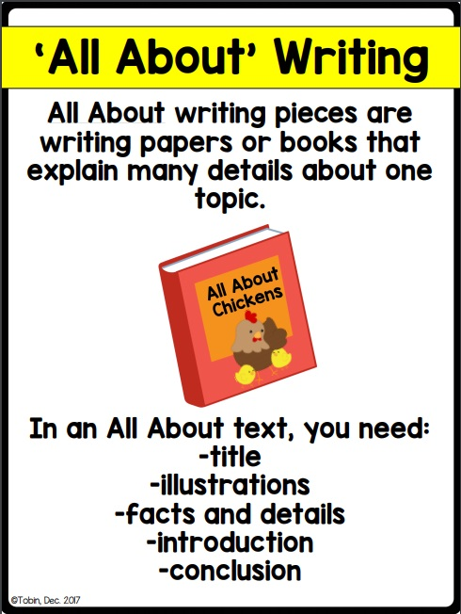
Planning Sheet

Introduction:

Fact:

Fact:

Fact:

Closure:

TITLE:

(Begin writing here…)

