<https://www.explorelearning.com/index.cfm?method=cuser.dsploginjoin>

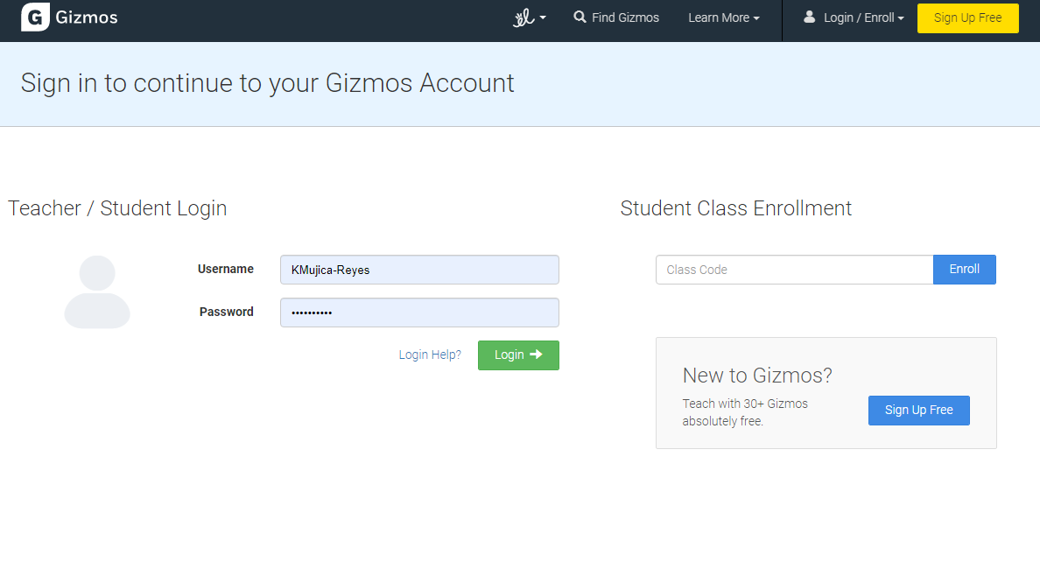

Add code, depending on what group you are, where it says Student class enrollment and press enroll

Example:

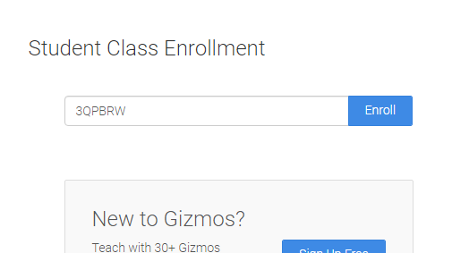

**Class Codes:**

**6A – 3QPBRW**

**6B – W4CVV2**

**6C – KQ5G33**

**6D – L3G9KR**

It’s going to take you to this page

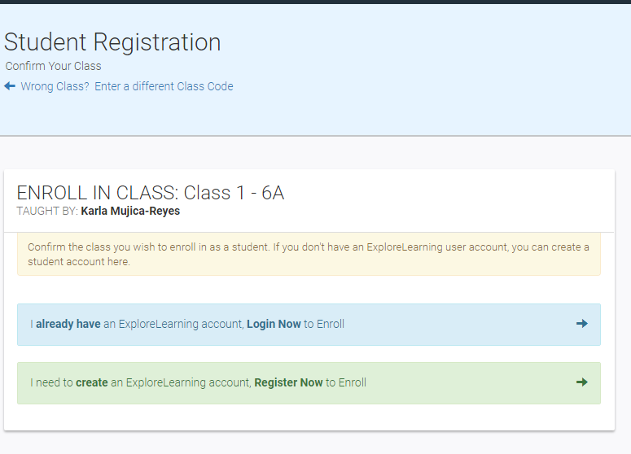

And you need to select/click on the blue option, I ALREADY HAVE AN EXPLORELEARNING ACCOUNT, LOG IN NOW TO ENROLL. After that you just log in with your information, if you forgot your Gizmo log in Ms. Johnston can retrieve it for you, and you are all set!

