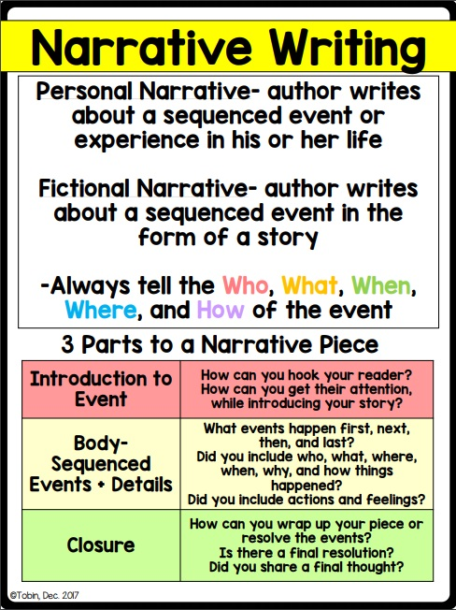
Pick one picture and write a story about it. Make sure to include first, next, then, last AND an introduction and conclusion.
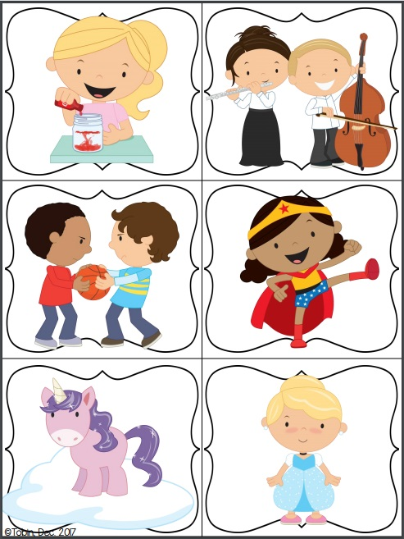
Planning Sheet

Introduction:

What happened first?

What happened next?

What happened after that?

What happened last?

Closure:

(Begin writing here…)

