Paper Helicopter Lab

Background Information: Paper helicopters can be made using a variety of different materials or papers. What causes them to spin? When the paper helicopter falls, air pushes up against the blades, bending them up just a little. When air pushes upward on the slanted blade, some of that thrust becomes a sideways, or horizontal, push. Why doesn't the copter simply move sideways through the air? That's because there are two blades, each getting the same push, but in opposite directions. The two opposing thrusts work together to cause the toy to spin.

Purpose/Problem: Use the scientific method to answer a question related to a paper helicopter. You choose the problem! Examples include, which size helicopter falls faster? What type of material makes the fastest falling helicopter? Does adding another paperclip affect the time it takes the helicopter to reach the ground?

Hypothesis: If (independent variable), then (dependent variable) because (scientific knowledge)

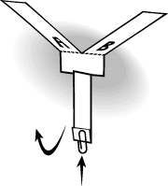
Materials:

- Paper
- Cardboard templates of helicopters
- Scissors
- Paperclips
- Stopwatch

Procedure:
- Build your helicopter according to your teacher’s instructions.
- Create your own procedure depending on what you are testing

Data Collection: Create and use a table to record your data. You should have 3 different helicopters; each tested a minimum of 5 times. Remember to include units.

Data Analysis: Use a graph to display your data. Be sure to make a GOOD graph. (title, labeled axes, a key if necessary, etc.)

Conclusion: Use the instruction on your “Parts of a Lab Report” paper to complete your conclusion.

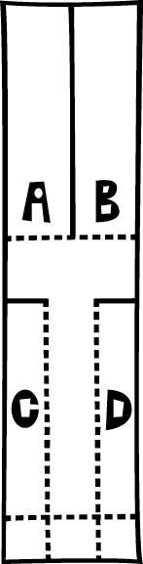
https://www.exploratorium.edu/science_explorer/roto-copter.html

