Balloon Race Car Challenge
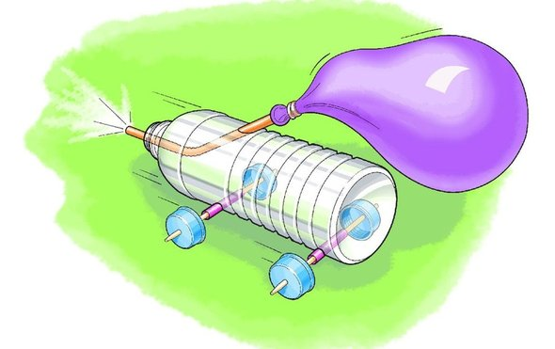
Objective: To create a balloon powered car that travels a minimum distance of 2.5 meters using only the materials and quantities listed below. The car must meet size limits in order to be tested and graded. If the car is made to include ANY additional materials that are not specified in the list below, it will be given a grade of ZERO and will not be tested.

This project will be broken down into 3 grades:
- Design: The car should have 1 theme/sponsor. The theme should be clear. The design grade will reflect the amount of effort and creativity used to design the car. The car should have a neat appearance. You can print out designs to glue onto the car using regular typing paper. Part of the appearance of the car includes the sturdiness of the wheels and axle.
- Distance: Your car’s average distance will be ranked and compared to that of your classmates. The car that travels the farthest will receive the best grade!
- Lab report: Your car will be raced against the other cars in your class period. You will observe which cars work best/worst and then write a lab report which includes data regarding those observations.

***Each car will have 3 trials and the average distance of the trial will be recorded and compared to other cars from the same class period.

Requirements/Limitations:
Car Body Size limits (not counting inflated balloon):
Maximum length: 22 cm Maximum width: 12 cm
- The car must roll in a straight path unassisted
- The car must have 4 functioning moving wheels
- Must have a well displayed theme/sponsor
- The car must move freely when placed on a flat surface and inflated balloon is released. You will NOT be allowed to provide even the slightest push to get your car going.
- The car’s wheels should not need adjustment prior to its placement on the flat surface.

Materials List (Do not exceed material quantities list. Do not use any other materials)

Power:
- 9” balloon (1)
Body:
- 500mL water bottle (1)
- Empty cereal box (2)
- Cup (2)
- Paper towel/toilet paper roll (1)
- Cardboard (1)

Axles:
- Unsharpened pencils (2)
- Straws (any size) (5)
- Wooden dowels/skewers (2)
- Popsicle sticks (4)

Tools:
- Scissors
- Hammer
- Hot glue gun
- Box cutter
Join parts together:
- Hot glue
- Rubber bands
- Scotch tape (1 roll)
- PlayDoh (1 small tub)
Wheels:
- CDs (4)
- Bottle caps (4)
- Spools (4)
- Lifesaver mints (4)
- Cardboard (4)

Tentative Build Dates: You may only build during class time, no building outside of class time is allowed.

BUILD DAY 1 & SUPPLIES CHECK: Wednesday, 2/3 & Thursday, 2/4*

BUILD DAY 2: Friday, 2/5* & Monday, 2/8

BUILD DAY 3: Tuesday, 2/9* & Wednesday, 2/10*

BUILD DAY 4 & PRE-RACE TRIAL: Thursday, 2/11 & Friday, 2/12*

RACE DAY: Thursday, 2/18* & Friday, 2/19

LAB REPORT DUE: Wednesday, 2/24 & Thursday, 2/25*

*Indicate when period 1 will build/due date.

Blog:

All students should have created their account here: https://edublogs.org/?join-invite-code=8141498-mastperez

After each build date, you will be expected to blog about your building experience and submit by 6pm the following day. Each build day blog post will have requirements, such as how many and what type of pictures to include, questions to answer, and more.

Each class period will have an editor or several editors, who will approve posts. Once posts are published, students will be responsible for commenting on at least two of their classmate’s posts. These comments should include thoughtful responses, critiques, and/or tips in at least two or more sentences.

The blog grades will be calculated based on the following criteria:
- Timeliness (Were they submitted on time?)
- Grammar/spelling (Were they written appropriately?)
- Content (Were they used to answer and provide required information?)

