1. Which equation represents the model? 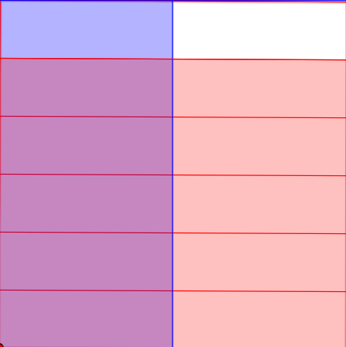
A) $\frac{1}{2}$ x $\frac{5}{6}$ = B) $\frac{1}{3}$ x $\frac{2}{4}$ = C) $\frac{5}{6 }$ x $\frac{2}{4}$ = D) $\frac{3}{4}$ x $\frac{1}{3}$ =

.

2. Which equation represents the model? 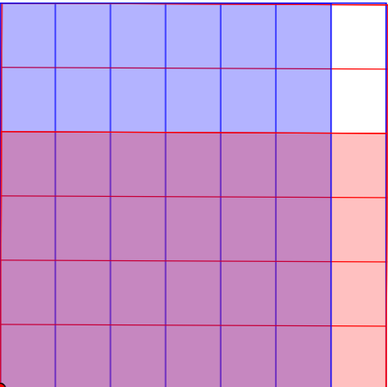
A) $\frac{3}{4}$ x $\frac{5}{6}$ = B) $\frac{6}{7}$ x $\frac{4}{6}$ = C) $\frac{2}{6 }$ x $\frac{2}{4}$ = D) $\frac{4}{4}$ x $\frac{1}{3}$ =

3. Which equation represents the model? 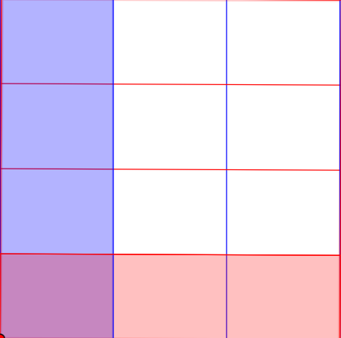
A) $\frac{3}{4}$ x $\frac{5}{6}$ = B) $\frac{6}{7}$ x $\frac{4}{6}$ = C) $\frac{2}{6 }$ x $\frac{2}{4}$ = D) $\frac{1}{4}$ x $\frac{1}{3}$ =

4. Solve equation. $\frac{2}{4} x \frac{3}{5}=$

5. Solve equation. $\frac{8}{9} x \frac{7}{8} =$

6. $\frac{2}{2}$ x 1$\frac{1}{3}$ will be ____________ 1$\frac{1}{3}$ .
A) Equal to B) Less than C) Greater than

7. $\frac{2}{3} x \frac{1}{2}$ will be ___________ $\frac{1}{2}$.
A) Equal to B) Less than C) Greater than

8. $2 x \frac{3}{4}$ will be ___________ $\frac{3}{4}$.
A) Equal to B) Less than C) Greater than

9. $\frac{4}{5} x 1$will be __________ $\frac{4}{5}.$
A) Equal to B) Less than C) Greater than

10. $\frac{1}{10} x 1\frac{1}{5}$ will be _______ $1\frac{1}{5}.$
A) Equal to B) Less than C) Greater than

