Waves, Sound & Light, Electricity & Magnetism Test Study Guide
Vocabulary: Create your own definitions for the terms below.
- Mechanical wave
- Electromagnetic wave
- Doppler effect
- Circuit
- Resistor
- Permanent magnet
- Magnetic field
- Electromagnet

Study Questions Answer the following questions to the best of your abilities.
- Describe two differences between transverse and compressional (longitudinal) waves.
- Draw and label the following on a transverse & compressional wave (longitudinal): crest, trough, amplitude, rarefaction, compression, wavelength.
- How are mechanical waves different from electromagnetic waves? Give two differences.
- List the waves of the electromagnetic spectrum from longest wavelength to shortest. What is the relationship between frequency, wavelength and energy?
- Answer each question below and define your answer.
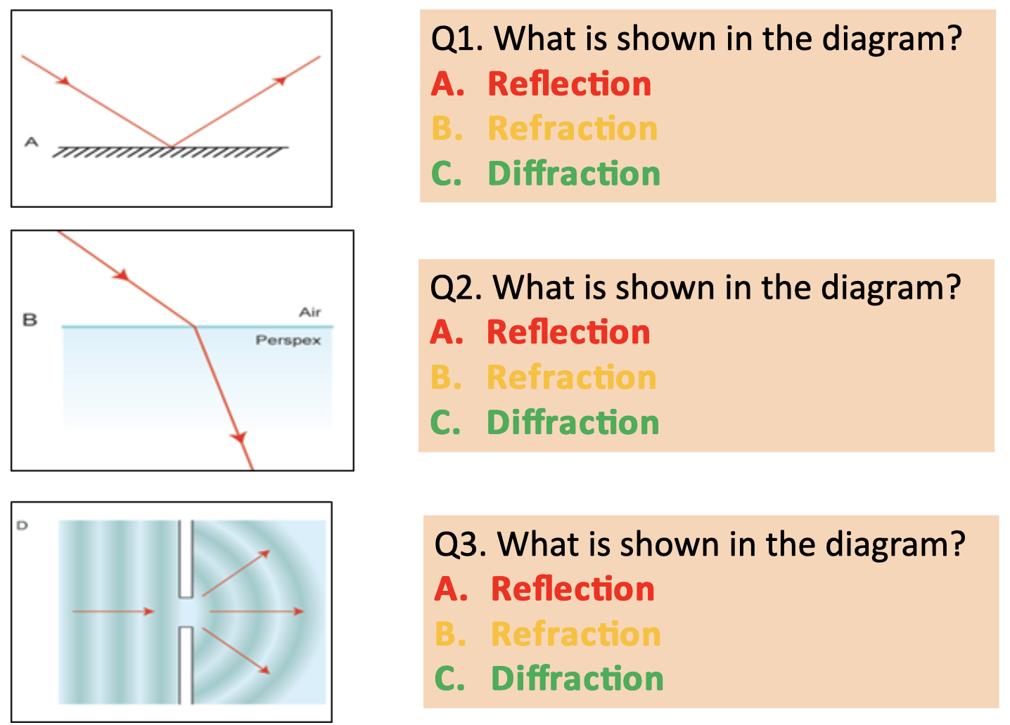
- How are pitch and frequency related?
- Explain what happens to sound waves during the Doppler effect.
- Create and solve TWO word problems using the wave speed formula. (v = f * λ)
- Why do sound waves travel the fastest through warm and solid materials while light waves travel the fastest through empty space?
- How does electricity flow through a circuit?
- What are the units used for the following: current, charge, resistance and voltage?
- Create and solve TWO word problems using Ohm’s Law (I = V/R)
- What is an advantage of using a parallel circuit as opposed to a series circuit?
- How do atoms create magnetic properties in some objects?
- What creates Earth’s magnetic field?
- How is the right-hand rule used to find the North pole of a magnetic object?
- Review your Series Circuits and Parallel Circuits Worksheets and be able to complete similar questions on the test.

More review:
Look over class notes and practice handouts covering these topics.

Review Edgenuity lessons 10.18, 10.21, 12.7. 10.14, 3.4 and 10.15 for more study material.

How do Magnets Work?
https://www.youtube.com/watch?v=hFAOXdXZ5TM

Magnetism Review
https://www.youtube.com/watch?v=s94suB5uLWw

Right Hand Rule
https://www.youtube.com/watch?v=LAnRTNwrFMo

