Matter and Its Changes
Unit Benchmark Test

 Salim blows up a new balloon and then lets the air out. He examines the physical change he caused to the balloon.
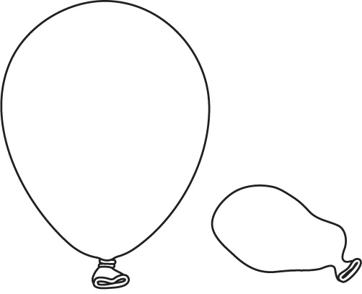
Which best describes the physical change in the balloon?
 change in size
 change in color
 change in position
 change in number of pieces
 SC.4.P.9.1
 Elise helps her teacher create a bulletin board showing different types of physical changes. The bulletin board has a folded piece of paper, a beach ball filled partially with air, and a piece of cloth with a rip in it. Which of the following could Elise add to the bulletin board to show another type of physical change?
 a flat bicycle tire
 a picture of melting ice
 a piece of foil with a cut in it
 a wire that has been bent
SC.4.P.9.1
 Ella has to write a research paper on physical changes. Which gives the best definition of a physical change?
a change that gives off heat
a change that causes bubbles to form
a change in size, shape, or state
a change that makes a new substance
SC.4.P.9.1
 Jayden adds salt to a pot of boiling water. Which best explains why adding salt causes a physical change?
the water changes color
the salt dissolves in the water
the water changes temperature
the salt burns in the boiling water
SC.4.P.9.1
 Adela sees her grandmother’s teapot on a shelf. The teapot is silver and has some tarnish on the outside. What does the tarnish indicate?
change of state
physical change
chemical change
change of texture
SC.4.P.9.1
 Tony places some iron nails on a wet shelf in his garage. What will likely happen when the nails come in contact with air?
The nails will rust.
The nails will melt.
The nails will bend.
The nails will burn.
SC.4.P.9.1
 Fireworks manufacturers create different colored explosions using different chemicals. A firework with copper can give off blue sparks. A firework with aluminum inside burns white. What claim tells what copper fireworks and aluminum fireworks have in common?
Both decay at a slow rate.
Both rust in contact with air.
Both tarnish when they explode.
Both explode because of a chemical reaction.
SC.4.P.9.1
 A landscape designer suggests the Ling family place an iron railing on the patio that overlooks a lake. Mr. Ling thinks that the water from the lake, the iron railing, and the air will cause a problem over time. What might happen to the iron railing because of the water and air?
The iron railing will rust.
The iron railing will burn.
The iron railing will bend.
The iron railing will tarnish.
SC.4.P.9.1
 Scuba divers use light sticks to light their way under water. To use a light stick, a scuba diver snaps the stick to mix two substances. The substances inside give off light when they mix. What evidence tells you that light sticks use a chemical reaction?
Scuba divers use light sticks.
The light stick can light up only once.
Two substances mix when the light stick is snapped.
The light sticks are the same as children’s glow sticks.
SC.4.P.9.1
 Bela is picking tomatoes from her garden. She finds a tomato on the ground that is soft and runny. Which claim is best supported by the evidence?
The tomato rotted, which is a chemical change.
The tomato moved, which is a chemical change.
The tomato deflated like a flat tire, which is a physical change.
The tomato ignited like a firecracker, which is a chemical change.
SC.4.P.9.1
 Sara is watching television when the power goes out. When she walks to the kitchen to get a candle, she knocks over a chair. She lights a match and holds it to the wick of the candle. She uses the light from the candle to find her way to the chair, which she picks up and sits in. Which of the events was a chemical change?
losing power
lighting the match
knocking over the chair
sitting in the chair
SC.4.P.9.1
 While Lee is babysitting Jimmy, Jimmy falls and cuts his hand. Lee pours peroxide on the cut. The peroxide bubbles when it touches the blood. Finally, Lee puts a bandage on the cut. Which is an example of a chemical change?
the hand bleeding
the peroxide bubbling
the bandage covering the cut
Lee babysitting Jimmy
SC.4.P.9.1
 Keeping a swimming pool safe to swim in takes a great deal of work. Which demonstrates how a chemical change keeps the water safe to swim in?
running the water through a filter
removing leaves from the water
adding chlorine to kill bacteria
vacuuming dirt from the pool
SC.4.P.9.1
 Hardware stores help people make, build, and repair things around the house. Which describes something that could most likely cause a chemical change?
sandpaper used to make wood smooth
a drill that makes a hole in concrete or brick
a grinder that turns a piece of metal into a key
a powerful glue that is formed when two different liquids are mixed together
SC.4.P.9.1
 Artists use chemical and physical changes when creating different works of art. Which statement best describes a physical change an artist might use?
Saltwater gives a copper sculpture a green tarnish.
Film and paper in a special liquid form a photograph.
Soft gray clay is heated and becomes hard and white.
Carving a piece of wood with a blade makes the wood into a bowl.
SC.4.P.9.1
 Aliya’s bike is made of steel. When she isn’t riding her bike, she parks it outside on the back porch. One day, it rained, and Aliya’s bike got wet. How can Aliya help keep her bike from rusting?
wash her bike
ride in the rain
wipe the water off her bike
spray her bike with the hose
SC.4.P.9.1
 One spring, two families bought new metal furniture for their porches. Two years later, the Flaherty family’s furniture is very rusty. Next door, the Ortiz family’s furniture is not rusty at all.
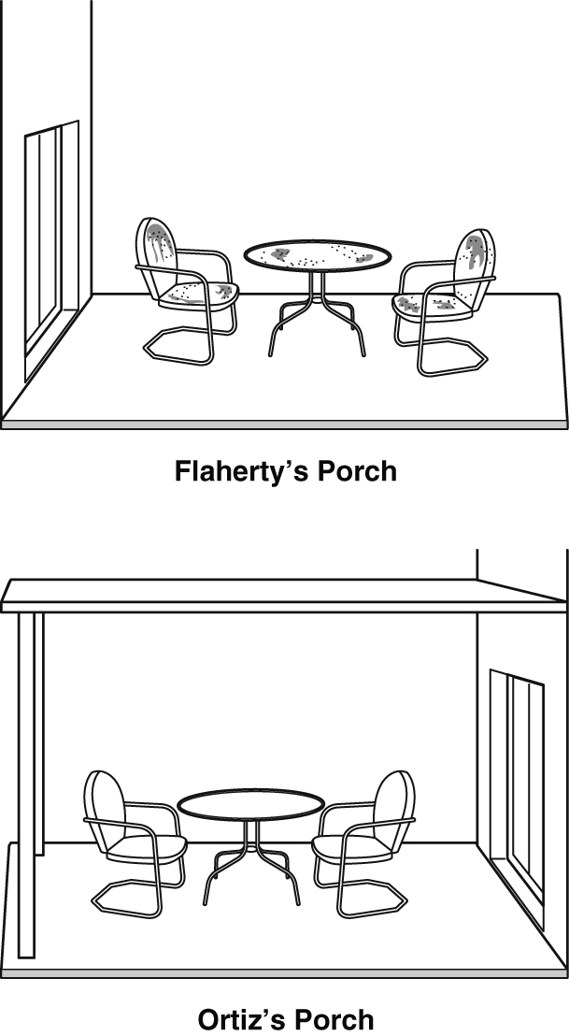
Why is Flaherty’s furniture rusty when the Ortiz family’s furniture is not?
The Ortiz’s porch has a roof, so their furniture stays cool.
The Ortiz’s porch has a roof, so their furniture gets little wind.
The Flaherty’s porch has no roof, so their furniture stays in the sunlight.
The Flaherty’s porch has no roof, so their furniture gets wet when it rains.
SC.4.P.9.1, SC.4.N.1.3
 Two friends used steel wool to sand model airplanes. When they finished, one girl put her steel wool on the dry workbench in the garage. The other girl rinsed her steel wool in water and set it on the dry workbench.
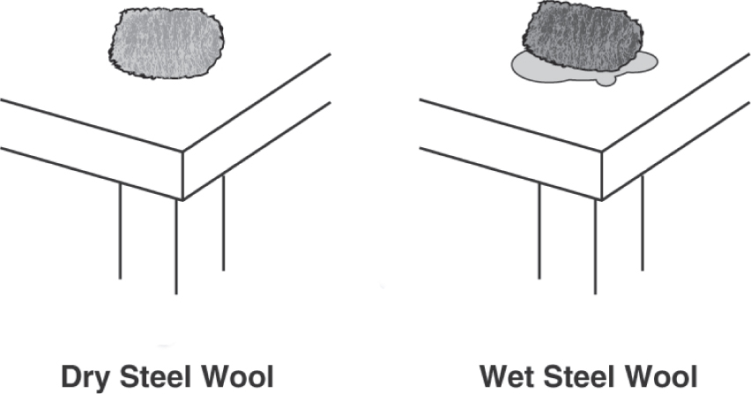
Which claim tells what you expect to observe after a week has passed?
Both pieces of steel wool have rusted.
The dry steel wool is the only piece of steel wool that has rusted.
The wet steel wool is the only piece of steel wool that has rusted.
Neither piece of steel wool rusted.
SC.4.P.9.1, SC.4.N.1.3
 A scientist was testing different materials to see which rusted the quickest. Each material was placed in water for the same amount of time and then stored in the same room. The scientist is trying to decide how often to observe the materials to see which ones rust the quickest. Which of the following should the scientist do?
observe the materials once a month
observe the materials once a week
observe the materials once a day
observe the materials every hour
SC.4.P.9.1, SC.4.N.1.3, SC.4.N.1.7
 The class discussed different things they could do to a piece of wood. Which of the following would be a chemical change?
The piece of wood could be ground up and made into mulch for a garden.
The piece of wood could be broken up into smaller pieces to make tent pegs.
The piece of wood could be nailed to another piece of wood.
The piece of wood could be burned in a stove to heat some rooms.
SC.4.P.9.1

